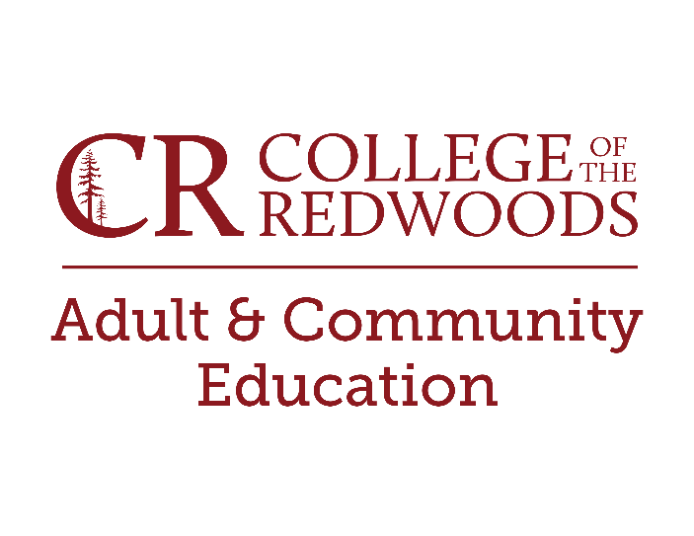
Potential Sponsorship Opportunities
Humboldt Workforce Coalition
Location: 409 K St., Eureka
Phone: 707-441-5627

Del Norte SMART Workforce Center
Location: 875 5th Street, Crescent City,
Phone:707-464-8347

Are you on any type of Local, State, or Federal Assistance?
Some examples:
Department of Rehabilitation
Worker’s Compensation
CalWORKs
CalFresh
Welfare to Work
Talk to your case worker to see what is possible.
Are you part of a Native American Tribe?
Check with your Tribal Education Office or,
Northern California Indian Development Council

Family/Friends/Employers – People tend to be willing to pay for education.

