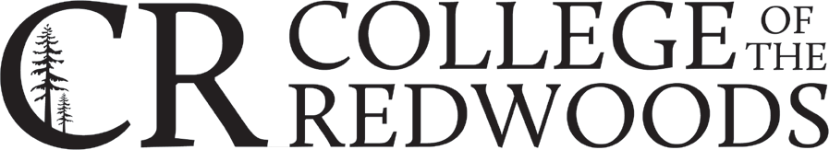

Assessment Handbook
August 2021

To the CR Community,
Assessment at College of the Redwoods is an ongoing process where student learning outcomes are defined, student success in achieving those outcomes is measured, and assessment results are used to improve our curriculum and services. One way we encourage student success is through learning outcomes assessment.
Assessing student learning outcomes gauges what students have learned in the context of program/course expectations and then documents the resultant improvements to program and course delivery. Our assessment process is based on the following seven assumptions:
- All levels of assessment should inform and build upon the others.
- All faculty and staff should be actively involved.
- Assessment should be embedded within regular course or program activities whenever possible.
- Assessment is an ongoing process.
- Assessment is concerned with evaluating the effectiveness of programs, courses, and services, not individuals.
- The results of assessment activities should be clearly linked to program improvements.
- The results of assessment activities should be publicly available.

Thanks in advance for your good work.
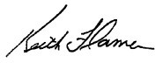

Dr. Keith Flamer President/Superintendent
(updated August, 2023)

Table of Contents
Assessment Handbook 1
Table of Contents 2
Introduction and Overview 5
The Assessment Committee 5
Mission 5
Scope 5
Principles of Assessment 6
College of the Redwoods Assessment Philosophy 8
Frequently Asked Questions (FAQs) 11
Where to Find Resources and Information 15
Academic Senate of College of the Redwoods 15
Academic Senate of California Community Colleges 15
Assessment Committee 15
Curriculum 15
Distance Education 15
The Assessment Process at College of the Redwoods 16
Overview: The Assessment Cycle 16
Course Assessment 16
The Three-year Assessment Plan 17
The Annual Assessment Calendar 17
Assessment Reporting: The “Legacy” Assessment System and eLumen 18
Program Outcome Mapping 20
For Individual Faculty 20
Updating the Program Outcome Map Using the Curriculum Workflow in eLumen 23
Program Mapping For Division and Department Coordinators 23
Quick Guides 24
Course-Level Assessment Quick Guide 24
Program-Level Assessment Quick Guide 25
Student Services Assessment Quick Guide 26
Assessment Methodology 28
Introduction 28
Authentic Assessment 28
Defining and Measuring Student Learning Outcomes 28
Tips for Outcomes Development 28
Indirect vs. Direct Assessment Methods 29
Qualitative vs. Quantitative Assessment Methods 31
Scoring Outcomes 32
Student Learning Outcomes and Curriculum Design 33
Designing Backwards from the Outside In 33
Formative and Summative Assessment 34
“Closing the Loop”: Using Assessment Results in Decision-Making 34
Student Support Services Assessment 38
Student Learning Outcomes in Student Support Services 38
Examples of Learning Outcomes for Student Services 39
References 40
Appendix A: Glossary of Assessment Terms 41
Appendix B: Bloom’s Taxonomy 47
Appendix C Assessment Tutorials 52
For Student Services Assessment 52
For Individual Faculty 52
For Division Coordinators and Department Coordinators (Deans, Associate Deans, Directors, Assistant Directors, Lead Faculty) 52
The Annual Assessment Calendar 54
Instructional Assessment Timeline 54
Aug./Sep. 54
Sep./Oct. 54
Nov./Dec. 56
Jan./Feb. 56
Mar/Apr. 57
May 57
Student Services Assessment Timeline 58
July 58
Sep./Oct. 58
Oct -June 58

Introduction and Overview
The College of the Redwoods Assessment Handbook provides a framework for continuous improvement of student learning and a commitment to program excellence. This handbook provides staff and faculty at College of the Redwoods (CR) assistance in the development and assessment of courses learning outcomes (CLOs) and program level outcomes (PLOs).
CR uses assessment to determine the effectiveness of administrative, academic, and student service programs. The intrinsic value of the assessment process is evident throughout the cycle of identifying CLOs and PLOs (including general education and institution-wide outcomes), assessing these outcomes, interpreting the data, and using the data to improve programs. External mandates require appropriate, ongoing, meaningful assessment.
CR’s assessment process ensures that the achievement of PLOs and CLOs are measured by student performance. PLOs and CLOs drive curriculum development and classroom activities. Learning opportunities within programs are consistent and clearly map to outcomes determined by faculty and staff. The assessment process further ensures that successful program completion provides students with the requisite skills and abilities described in the General Education (GE) goals. Faculty teaching GE courses provide students with multiple, integrated learning opportunities to assure that students will be able to put into practice what they have learned through their academic experiences at CR.

The Assessment Committee

Mission
The Mission of the Assessment Committee (AC) is to ensure that adequate plans are in place for outcome assessment at all levels of CR. The AC supports the collaborative efforts of faculty and staff to enhance student success by providing guidance, assistance, and structure for continual improvement through outcome assessment.

Scope
The Assessment Committee provides guidance to committees and individuals about how and why assessment should be conducted, facilitates discussions and decision-making related to assessment work, offers training in all levels of assessment, and helps to ensure that outcomes assessment is embedded in college processes as directed by the Accrediting Commission for Community and Junior Colleges (ACCJC), the Western Association for Schools and Colleges (WASC), the California Community College Chancellor’s Office (CCCO), the Academic Senate for California Community Colleges (ASCCC) and other accreditation and governance organizations. The committee coordinates collegial dialogue and ensures that the assessment process is ongoing and sustainable at the department, program, and institutional level. The Assessment Committee envisions a college in which regular outcome assessment, and the review and interpretation of relevant data, inform all levels of department, program, division, and institution planning toward the goal of improving student learning and success.
To support its mission, the AC provides guidance to related committees including, but not limited to, the Program Review Committee, the Curriculum Committee, and the Enrollment Management Committee. The Assessment Committee functions in close connection with the Program Review Committee and the Institutional Effectiveness Committee to review disciplinary, programmatic, and institutional assessment plans and to assist in the use and improvement of assessment toward increasing the quality of student learning. Through its annual planning cycle, corresponding with Program Review and the Integrated Planning Model, the Assessment Committee promotes continuous improvement toward student success.

Principles of Assessment
College of the Redwoods draws inspiration for meaningful assessment from research-based best practices in the field. Student learning and success builds on this foundation. The “Nine Principles of Good Practice for Assessing Student Learning” (adapted from Astin et al., 1992) captures these essentials.

- The assessment of student learning begins with educational values.
Assessment is not a terminating process, but rather a mechanism for continual pedagogical improvement leading to greater student success. Educational values should drive not only what we choose to assess but also how we do so. When questions about educational mission and values are not considered, assessment can devolve into an exercise in measuring what’s easy, rather than a continual process of improving student success.

- Assessment is most effective when it reflects an understanding of learning as a multidimensional and integrated process that is actualized in performance over time.
Learning is a complex process. It entails not only what students know but how they can apply what they know. It involves not only knowledge and abilities but values, attitudes, and habits of mind that affect both academic success and performance beyond the classroom. Assessment should reflect these understandings by employing a diverse array of methods, including those that call for actual performance, using them over time to reveal change, growth, and increasing degrees of integration. Such an approach aims for a comprehensive and accurate picture of the learning process, and therefore a firmer basis for improving students’ educational experience.

- Assessment works best when clear, explicit outcomes exist.
Assessment is a goal-oriented process. It entails comparing educational performance with educational purposes, expectations, and pedagogies; those derived from the institution’s mission, from faculty intentions in program and course design, and from knowledge of students’ own goals. Where program purposes lack specificity or agreement, assessment, as a process, pushes a campus toward clarity about goals and what standards to apply and also draws attention to where and how students achieve program outcomes. Clear, shared, implementable outcomes are the cornerstones of useful and focused assessment.

- Assessment requires attention to outcomes but also, and equally, to the experiences that lead to those outcomes.
Information about outcomes is of high importance; where students “end up” matters greatly. But to improve outcomes, we need to know about student experience along the way – about the curricula, the teaching methods, and the kind of student effort that leads to particular outcomes. Assessment can help us understand which students learn best under what conditions. With such knowledge comes the capacity to improve the whole of their learning.

- Assessment works best when it is ongoing not episodic.
Assessment is a process the power of which is cumulative. Though isolated, “one-shot” assessment can be better than no assessment at all, improvement is best fostered when assessment entails a linked series of activities undertaken over time. This may mean tracking the process of individual students, or of cohorts of students. It may mean collecting the same examples of student performance or using the same assessment instrument during multiple semesters. The point is to monitor progress toward intended goals in a spirit of continuous improvement. Along the way, the assessment process itself should be evaluated and refined in light of emerging insights.

- Assessment fosters wider improvement when representatives from across the educational community are involved.
Student learning is a campus-wide responsibility, and assessment is a way of enacting that responsibility. Thus, while assessment efforts may start small, the aim over time is to involve people from across the educational community. Faculty play an especially significant role, but assessment questions can’t be fully addressed without participation by student support services, librarians, administrators, and the students themselves. Assessment may also involve individuals from beyond the campus (alumni/ae, trustees, employers) whose experience can enrich our judgment regarding the appropriate aims and standards of education. Thus understood, assessment is not a task for small groups of experts, but a collaborative activity; its aim is to achieve a broader based, better informed understanding of student learning, one that informs all parties with a stake in educational improvement.

- Assessment makes a difference when it begins with issues of utility but then goes on to illuminate the issues people care about.
Assessment recognizes the value of gathering data in the process of improvement. But to be useful, we must connect information to the issues or questions that people really care about. This implies an approach to assessment that produces evidence that relevant parties will find credible, suggestive, and applicable to decisions that are relevant in those contexts. It means thinking in advance about how the information will be used and by whom. The point of assessment is not to gather data and return results; it is a process that starts with the questions of decisionmakers, which involves them in the gathering and interpreting of data, and that informs and helps guide continuous improvement.

- Assessment is most likely to lead to improvement when it is part of a larger set of conditions that promote change.
Assessment alone changes little. Its greatest value is realized on those campuses where the quality of teaching and learning is valued and pursued. On such campuses, the push to improve educational performance is a visible and primary goal of leadership; improving the quality of undergraduate education is central to the institution’s planning, budgeting, and personnel decisions. On such campuses, knowledge gained from assessment is an integral part of decision making, and therefore eagerly gathered.

- Through assessment, educators endeavor to meet their responsibilities to students and to the public.
There is a compelling public stake in education. As educators, we have a responsibility to the public to provide information about the ways in which our students meet goals and expectations. But that responsibility goes beyond the reporting of such information; our deeper obligation, to ourselves, our students, and society, is to improve. Those to whom educators are accountable have a corresponding obligation to support such attempts at improvement.

College of the Redwoods Assessment Philosophy
College of the Redwoods Academic Senate
The College of the Redwoods’ Academic Senate defines our assessment philosophy and related activities at the college as the following:

- Why assess student learning outcomes?
The purpose of student learning outcome assessment is to document and improve the college’s programs and courses. When we assess our students’ learning, we can identify which of our teaching practices have been successful and which have not, thus enabling us to modify our teaching practices in order to increase success. When we identify course learning outcomes and share them with our students, we encourage students to become more actively involved in their own learning.

- What is assessment?
Assessment is an ongoing process aimed at understanding and improving student learning. It involves making expectations explicit and public; setting appropriate criteria and standards for quality learning; systematically gathering, analyzing, and interpreting evidence to determine how well performance matches those expectations and standards; and using the resulting information to document, explain, and improve performance. Assessment helps us create a shared academic culture dedicated to assuring and improving the quality of higher education (AAHE Bulletin, 1995). Assessment is an ongoing process, which ideally permeates the institution. The assessment cycle involves both gathering information and using that information to modify and improve teaching and student learning. Outcomes assessment is not for the purpose of evaluating an individual student or a faculty member’s performance, its function is to increase student success by improving programs.
- Who will conduct outcomes assessment?
It is within the purview of the faculty of College of the Redwoods to identify the core knowledge and skills that our students need to master, in keeping with the college’s goals, and to shape, design, and disseminate institutional assessment, as instructed by the Academic Senate. Student services and administrative programs also define, measure, and assess outcomes for continual evaluation and improvement.

- Who will develop the processes of assessment?
Development of the criteria assessing student progress is within the purview of the faculty of College of the Redwoods. Assessment is an ongoing process open to modification and improvement. Faculty and staff shall maintain ownership of program and course outcomes, student services outcomes, and administrative area outcomes and assessment processes associated with each.

- What assessment is used for?
At College of the Redwoods, ongoing assessment of student learning outcomes helps us understand, and thereby improve, student learning through informed decision making and planning.
Assessment of student learning may include multiple measures. As such, the measures used by department/programs may vary across the college. Specific measures may depend upon both the learning goals and the methods of assessment most appropriate for specific curriculum. More specifically, assessment helps us:

  - Improve services, feedback, guidance, and mentoring to students to help them better plan and implement their educational programs,
  - Design and improve programs and courses,
  - Plan at the department and program level,
  - Identify shared definitions and measurable benchmarks for evaluating student abilities,
  - Understand how groups of students experience the college differently and respond appropriately to the needs of all students,
  - Align and coordinate courses within and across disciplines,
  - Align and coordinate courses and programs with external institutions’ requirements as necessary,
  - Continuously reflect, refine, and modify teaching and learning practices.

- What assessment is not used for?
Effective assessment relies upon a climate of trust and freedom of inquiry. As faculty and staff at College of the Redwoods, we perform assessment of student learning and control the results of our assessments. Data gathered in support of all assessment work shall be aggregated so as to remove the identity of any students, faculty, and/or staff.
Therefore, College of the Redwoods:

  - Will not use assessment of student learning as an end in and of itself. Assessment that does not help us promote student learning is a waste of time.
  - Will not use assessment of student learning punitively or as a means of determining faculty or staff salaries or rewards. The purpose of assessment is to evaluate student learning and improve programs, not to reward or punish faculty or staff.
  - Will not use any single mode of assessment to answer all questions or strictly determine program decisions.
  - Will not use assessment in a way that will impinge upon the academic freedom or professional rights of faculty or staff. Individual faculty and staff must continue to exercise professional judgment in matters of grading and discipline.
  - Is not expected to assess all students to learn about the effectiveness of our programs and policies; a subset is sufficient.
  - Will not assume that assessment is only quantitative. While numerical scales or rubrics (such as the four-point grading scale) can be useful, their accuracy always depends upon the clear understanding of the concepts behind the numbers. We will not assume that assessment is only grading.
  - Will not use assessment only to evaluate the end of the student’s experience or merely to be accountable to outside parties.
  - Will not use assessment data for evaluation of faculty.
  - Will not use assessment data for program/discipline reduction or elimination.

- What is the college’s role in assessing student learning?
Assessment of student learning can significantly enhance the college’s ability to fulfill our mission and goals. Consequently, the college supports assessment of student learning as a valued and important process and provides successful models for developing assessment.

- How will we use assessment of student learning?
When faculty chooses to assess student learning, we will:

  - Always seek multiple methods of assessing student learning rather than relying on any single method.
  - Assess those skills, attitudes, behaviors, and knowledge that our faculty judge to be important and valuable.
  - Assess the ongoing progress of students throughout their experience at College of the Redwoods.
  - Use assessment processes and instruments to accommodate and encourage creativity and originality from students.
  - Explain the purposes of assessment so that staff, students, and the community can see why assessment is done.

In conclusion, faculty and staff shall facilitate and drive the process of assessment of student learning in their own programs. This process includes the selection of the methods chosen and designed for assessment., administration of the assessment, analysis of the assessment data, and use of the assessment results.

This Academic Senate document is based upon the work done by College of Marin, Palomar College, Modesto Junior College, Coastline Community College, and El Camino College.

Frequently Asked Questions (FAQs)
Assessment is a type of action research to help us gather indicators that will be useful for improving student learning through our curriculum and teaching strategies. It focuses on student learning and what the student will be able to do and not so much on what we are going to teach.
The following Q & As will attempt to provide answers to some frequently asked questions that may further your understanding of the assessment process.
- Why do we assess student learning?
To do assessment for the goal of doing assessment and writing a report would be a waste of time. Link your assessment practices to compelling, powerful, and consequential processes such as capstone assignments, department review, or program validation. You can link it to curriculum revisions, distance learning, retention, service learning, and improving student learning and teaching strategies.
There is considerable evidence that assessment drives student learning and curriculum. Most importantly, our assessment tools can tell our students what we consider to be important and communicate our expectations of what the student will do to be successful in the course or program. They will learn what we guide them to learn through our assessments. By using appropriate assessment techniques, we can encourage our students to raise the bar. Think of assessment for learning as the “learning process” where both teacher and student receive significant feedback to improve learning.
It is not the assessments themselves that hold the importance, but the changes in pedagogy and process assessment illicit that are important. Change and innovation take courage, but they’re also at the heart of the teaching profession.

- I administer tests and give grades. Isn’t that assessment?
It depends. Tests and quizzes are typically an evaluation of learned material. Assessment involves a sample of behavior from your student that can be observed and judged based on specific criteria developed and assessed in multiple modes and contexts with a focus on the learning process. For example, a project, presentation, writing assignment or lab are useful for evaluating student learning and, if designed well, can also assess learning outcomes. Traditional testing methods are limited measures of student learning and of limited value for guiding student learning. We cannot just say that 73% of our students are getting As and Bs, so we must be doing okay. A letter grade itself does not give enough information about the learning that is occurring.

- Are learning outcomes specific tasks that the student will perform?
No, learning outcomes are not tasks. Learning outcomes are abilities that can be developed, improved upon, and assessed.

- What is an outcomes-based course?
An outcomes-based course utilizes multiple learning opportunities through which the student can achieve the learning outcomes.

- How does the assessment of learning outcomes help faculty?
It provides teachers with useful information about their students, including the quality of and readiness for learning. Ongoing assessment informs the teachers about the pace and progress of student learning in their classroom.

- Is this something extra for me to do? Who should be doing assessment?
No, assessment does not need to be extra. You are performing assessment throughout your course. It’s those learning opportunities that you have designed in your curriculum where you can give your students on-going feedback in order to improve learning. The primary differences are that assessment targets specific outcomes, rather than giving grades based upon multiple criteria, and assessment is concerned with how the entire group of students is performing, rather than the grade of a single individual. Only faculty who guide the learning process can identify the student learning outcomes for their courses and programs. It is the faculty who teach in their program who can interpret the results and recommend improvements in pedagogy and curriculum.

- How can I assess attitudes and understandings that are not quantifiable?
A common misunderstanding is that assessment requires all aspects of learning be reduced to statistical measures. The impetus of assessment is objective results such that anyone will know that the students are meeting the learning outcomes; however, this need not be quantitative. If the faculty identify as an important result that which is qualitative, the process simply asks them to specify some objective means to demonstrate that the results are happening as intended.

- Do student assessment results affect faculty evaluation?
No. We are focusing on improving the course and program. The expertise and professional judgment of the faculty informs assessment. The faculty in an academic program, interpreting the results of an assessment, might collectively decide to give more attention to certain outcomes, and might recommend changes in pedagogy. Program improvement leading to increased student success is the goal of assessment, not the evaluation of the faculty involved.

- Why is the ACCJC making us assess?
To foster student learning and student achievement through the ongoing assessment of learning. Most faculty have been engaged in various types of assessment throughout their teaching careers and have found it to be a tool for understanding what their students are learning. Program improvement leading to increased student success is the goal of assessment.

- Are associate faculty involved?
Yes. Assessment of learning outcomes involves all faculty.

- What is the connection between the various levels of assessment?
The focus of assessment is student learning. The most significant educational interaction happens between students and faculty in the classroom or online. The individual class section is part of a course, and a course is part of a program. These levels reflect different, yet interrelated, facets of a student’s education.

- How will assessment improve learning?
Assessment is a tool by which we can communicate with our students about learning through learning opportunities and ongoing feedback. Assessment does not accomplish learning; it provides information to the student and the faculty who may use it to improve learning.

- How does classroom assessment relate to program assessment, and how does program assessment fit in with the College’s overall assessment efforts?
Classroom assessment involves assessing student learning in a particular course. This can be accomplished using Classroom Assessment Techniques (CATs), which are quick, ungraded, classroom assignments used to provide feedback for determining student understanding of material. It is an ongoing process with the primary purpose of improving course-level instruction and student learning.
Improvement is accomplished through an annual process where each program designs and implements an assessment plan, measures learning outcomes, analyzes the data collected, communicates the information, and uses these results to develop program plans aimed at improving student learning.
College assessment efforts include classroom assessment, program assessment, assessment of general education outcomes, and assessment of institutional learning outcomes. The goal of assessment of student learning at College of the Redwoods is to improve student learning, improve student success, and support the College in fulfilling its educational mission. Assessment provides evidence of how well CR is meeting its mission and helps identify areas for improvement. These improvements might include things like providing more research materials in the library, finding better means to communicate information about policy changes to students, developing more explicit rubrics for assignments, changing the requirements for a degree, and/or better utilizing feedback from advisory boards.

- How many faculty of a given program should participate in the assessment process?
All faculty, both full-time and part-time, are contractually obligated to participate in assessment. All have a stake in the success of their respective programs.

- How, why, or when should a department rotate courses to be assessed?
College of the Redwoods Assesses CLOs on a three-year cycle, during which time all instructional CLOs should be assessed at least once and all service area and administrative outcomes at least twice. Plans that determine when each program conducts outcome assessment can be found on the Assessment Plans, Reports, and Dialogue page on the CR Assessment webpage.
These three-year plans were built with the idea of allowing enough time to make changes and reassess within the cycle as needed, promoting meaningful and sustainable assessment and continuous improvement. To accomplish this goal, the Assessment Committee at College of the Redwoods determined it was best practice for all of a course’s outcomes to be assessed periodically, together in one semester, rather than incrementally (one outcome at a time). This enables faculty to determine if students are struggling to meet any of the outcomes, which may tell you something about the outcome, about course design, or about lesson planning. It also ensures there is sufficient data for program outcome assessment. Sometimes only one outcome in a course is mapped to a program outcome. Therefore, taking a snapshot of all a course’s outcomes together gives a better chance of having needed information when it comes time to do program assessment.

- How do faculty within a department identify student learning outcomes?
Some learning outcomes can be mandated by outside agencies or advisory boards. Others are identified through discussion among faculty who have tried to answer the question of what knowledge or skills their students should demonstrate upon exiting the course or program. Course-level outcomes, developed by faculty throughout the district who teach a subject, are included in each course outline of record (COR) that are approved by the Curriculum Committee.
Program-level outcomes are also developed by faculty who teach the courses included in a degree and certificate, but they reflect goals and skills that students should attain in the process of successfully progressing through and completing the program of study. While each course in a degree or certificate need not contribute knowledge related to every program outcome, they cumulatively should enable students to achieve those outcomes. Learning outcomes inform our curriculum, teaching, and assessment.

- Who chooses lead instructors/course coordinators for assessment in the department/discipline?
This is a departmental decision. Typically, your Dean or Director would facilitate this discussion.

- What is a program-level outcome?
Think about what your students will need to be able to DO “out there” (in the rest of life) that you are responsible for in your program?” (Stiehl & Lewchuk, 2002)
When developing your program outcomes, they should encompass several levels of learning (i.e., from basic to advanced courses) throughout the learning sequence of the program. One program outcome will encompass more than one course. Look at the big picture, not tiny details such as skills that are simply checked off.

- What’s the difference between an objective and an outcome?
In part, it’s a matter of terminology, but in practice, objectives in the context of course design describe skills, attitudes, and knowledge that once learned enable a student to perform an outcome. Objectives are content-centered and often too numerous, specific, or detailed to be assessed efficiently.
Outcomes in contrast describe the overarching capabilities that students develop through engaging the learning process; what they demonstrate through their ability to apply skills, attitudes, and knowledge. Outcomes are learner centered. They require the use of higher-level thinking such as analysis, synthesis, and evaluation in relevant contexts.

Adapted from COLUMBUS STATE COMMUNITY COLLEGE CENTER FOR TEACHING & LEARNING INNOVATION

Where to Find Resources and Information

Academic Senate of College of the Redwoods
https://internal.redwoods.edu/Senate/

Academic Senate of California Community Colleges
A Glossary of Student Learning Outcomes (2019)

Assessment Committee
The Assessment Process page (resources for conducting assessment): https://www.redwoods.edu/assess
The Assessment Committee page (membership, meeting notes): https://internal.redwoods.edu/Assessment

Curriculum
Resources about the Curriculum process can be found at: https://internal.redwoods.edu/senate/Curriculum/Curriculum-Handbook
Current Course Outlines of Record (CORs) can be found at: https://redwoods.elumenapp.com/public/

Distance Education
Information provided by the Instructional Technologist and Distance Ed Faculty Coordinator can be found at: CR-Online Faculty Resources and on the Keep Teaching Canvas Course Page.
Canvas by Instructure is the online Learning Management System (LMS) used at College of the Redwoods. With a few preliminary steps, faculty can use Canvas assignment rubrics to assess student learning outcomes and import the data into eLumen. To learn more about synchronizing your Canvas classes with eLumen, see the tutorial “Using Canvas for Student Learning Outcomes” (Appendix C).

The Assessment Process at College of the Redwoods

Overview: The Assessment Cycle
The College of the Redwoods Assessment Cycle is “…the process of collecting data from assessment, using that data to develop or modify curriculum, and then assessing the new or modified curriculum to collect data for ongoing modification or development” (ASCCC, 2019). Outcome assessment is an ongoing process of assessing student learning outcomes, evaluating program effectiveness, and using this information to continuously enhance student learning and improve student success.
College of the Redwoods plans and regularly assesses course-level outcomes (CLOs), program-level outcomes (PLOs), and General Education (GE) and Institutional Learning Outcomes (ILOs). Through this process, we determine the knowledge students have attained, ensure that students have sufficient opportunities to demonstrate this learning, and systematically gather, analyze, interpret, and discuss the evidence to determine how well student learning matches expectations of outcomes. We then use the resulting information to understand and improve programs. The process of assessing, analyzing, discussing, modifying, and reassessing is know as the assessment cycle.

Collaborative dialogue about the results of assessment allows us to identify strengths and opportunities for improvement and to implement program plans designed to achieve these goals. The continuous cycle of assessment and reassessment then determines the effectiveness of planning and action. The following is an overview of the process as it applies to instructional assessment. For more on learning support, student development, and student services assessment, please see the section, “Student Support Services Assessment” (below).

Course Assessment
Course assessment is that process in which faculty evaluate curriculum “as it is designed, taught, and learned. It involves the collection of data aimed at measuring successful learning in an individual course and improving instruction with a goal of enhancing learning” (ASCCC, 2019). Course assessment is done through classroom-based assessment (including the virtual classroom), which is “the formative and summative evaluation of student learning within a specific classroom” (ASCCC, 2019). Accordingly, the assessment cycle depends on effective classroom-based assessments (sometimes referred to as assessment activities or instruments) to gather evidence of student learning (also referred to as artifacts) as it pertains to a course’s set of outcomes (CLOs).

The Three-Year Assessment Plan
Ongoing assessment, improvement planning, and reassessment run on a continuous cycle. To track and manage this process, CR has adopted a three-year assessment plan for instructional programs, during which time all programs must at minimum assess all CLOs and PLOs at least once within this time period. Because the college uses periodic assessment, meaning that all outcomes in a course are assessed during the same semester, these three-year assessment plans are essentially schedules of when courses and their mapped program outcomes are to be assessed. There is also a General Education Outcome assessment plan and an Institutional Learning Outcome plan, both synchronized with the three-year CLO and PLO plans. Plans need to be inspected regularly and updated whenever courses and programs are proposed, changed, or discontinued.

The Annual Assessment Calendar
Nested within the three-year assessment plan, the Annual Assessment Calendar (See Appendix D) begins with the start of fall semester and runs to the completion of the academic year. There are three main components to the calendar. First, there are the Fall and Spring Assessment Conferences, as flex sessions prior to the beginning of each semester. At these flex sessions, program faculty convene in program assessment dialogue sessions to review and discuss the results of course assessments gathered from the previous year and to survey all recent assessments as they relate to overall program effectiveness. Programs will typically consider at least one program-level outcome per year, ensuring all program outcomes are assessed within a three-year period. Assessment dialogue and improvement plans are documented using a Program Assessment Dialogue Worksheet (PADs) and improvement plans resulting from program assessment dialogue are then included among the list of program plans in Program Review. Thus, rather than assessing and reporting on CLOs in isolation, course outcomes are reviewed together and used to assess program-level outcomes for the year by discipline/program faculty working together.
Next, there is the actual task of assessing student achievement of course learning outcomes (CLOs), carried out by individual faculty during the regular fall and spring semesters. At the beginning of each term, the associate deans and program directors (or their appointees) in each division create an assessment scorecard in eLumen for each course to be assessed, following the three-year assessment plan. Sometime during the semester, faculty teaching courses schedule for assessment decide upon and administer the activity used to assess the course outcomes. Upon conclusion, they report the results in eLumen, taking special care to complete the Reflection Template using comprehensive and meaningful narrative.
Then, there is General Education (GE) and Institutional Learning Outcome (ILO) assessment. GE and ILO assessment occur in parallel with regular CLO assessment, but as of this publication are conducted separately from the Assessment Conferences (although the output of all three processes is reviewed by the Institutional Effectiveness Committee). General education outcomes are assessed on a rotating semester basis, following a three-year plan. This typically takes place in a single meeting each semester, at which time those faculty who teach GE courses in the scheduled area review course assessments pertaining to those general education outcomes to determine if the college is meeting its goals. Institutional learning outcomes are evaluated on a rotating annual basis during the Institutional Effectiveness Summit, held each spring.

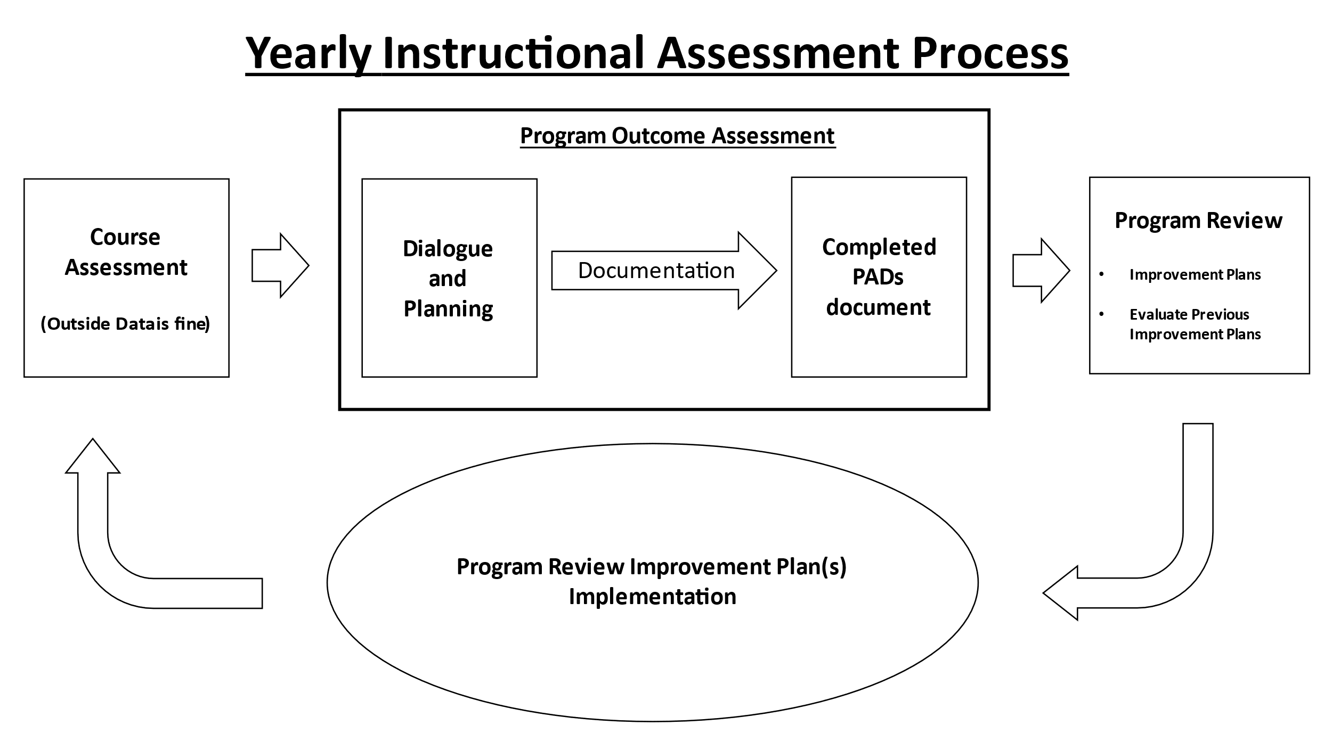

Program Outcome Mapping
This section of the handbook includes explanations and examples for mapping course level outcomes to program level outcomes. The objective of program mapping is to show how course-level outcomes (CLOs) help students achieve program-level outcomes (PLOs). PLOs are assessed primarily using CLO data but may include other methods such as capstone courses, advancement through a degree, or other relevant outside data. It is not expected that every CLO in every course within a degree will map to a PLO. However, all program outcomes need to be mapped to at least some course outcomes and course outcomes must be regularly assessed to capture sufficient data. With good course-to-program mapping, eLumen can be used to generate summaries of aggregated assessment data.
Subject matter experts within each degree or certificate develop the program outcome map for their area. They design CLOs to align with program outcomes and they update the map as needed during curriculum review. The next section shows you how to view and modify program maps.

For Individual Faculty
Individual faculty can view a read-only program outcome map for CLOs in the specific courses they are teaching. In the course dashboard, click the blue icon with a check mark immediately under the course title.
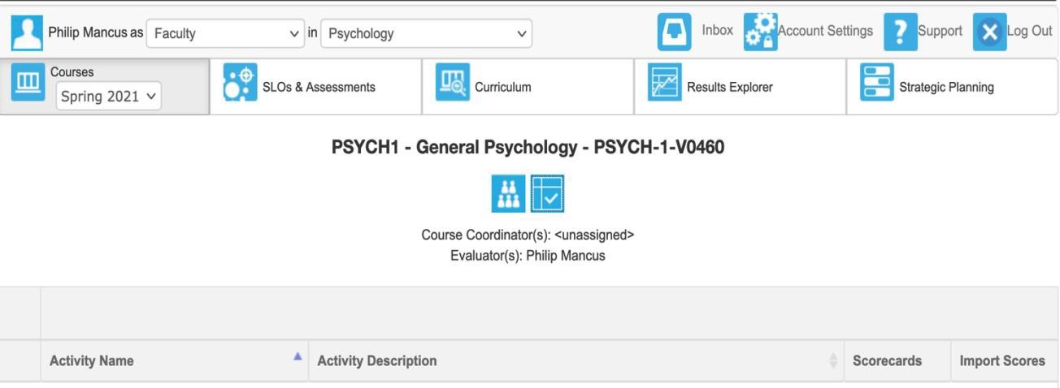
CLOs are listed down the first column with PLOs for each relevant program across the top. The boxes with green fields containing white checkmarks indicate that the specific CLO is mapped to the PLO. Any assessment data gathered on that course outcome will be used to determine student mastery of the PLO.
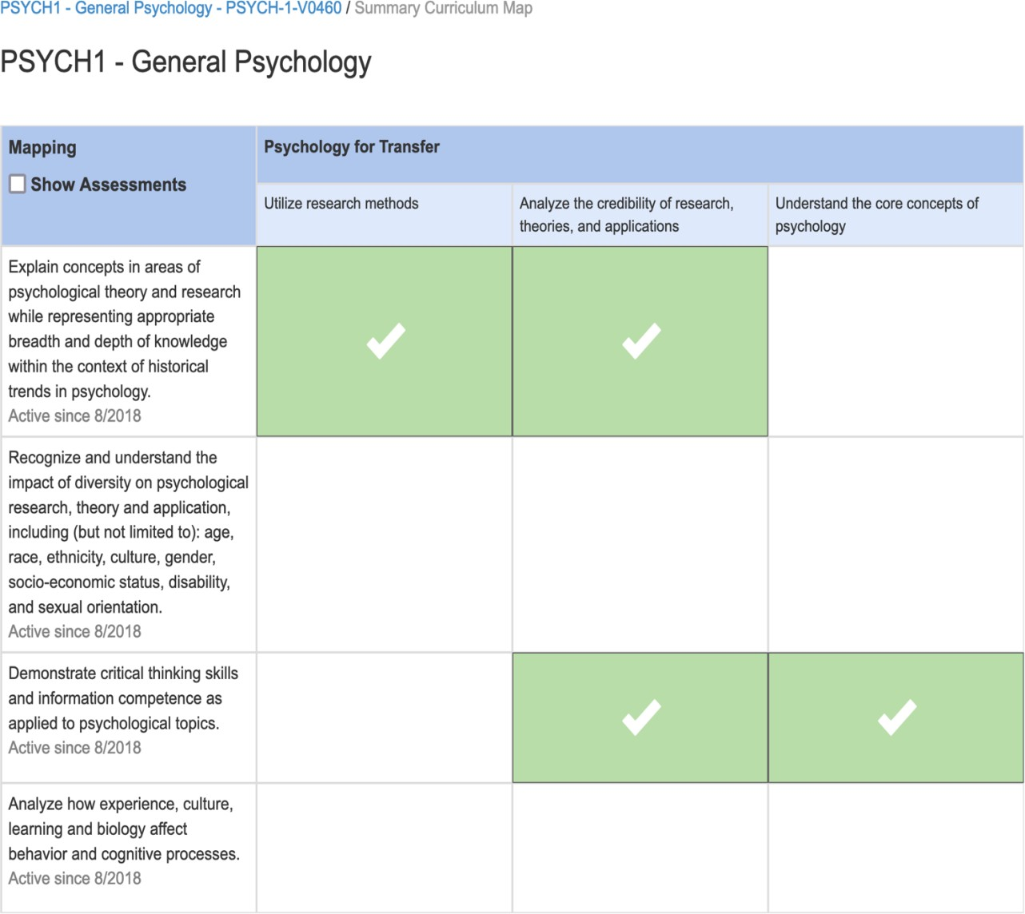

Individual faculty can also view the entire program outcome map for programs they are a part of. In eLumen, click “CLO & Assessments” and under the “CLOs” subtab set the “PLO Classes for Program” to the specific program you want. A list of the program outcomes appears. Select the “CLO Explorer” for any outcome and it gives you the courses that map to that PLO. You may choose to limit courses to within a discipline or include courses outside the discipline. In the examples below, the CLO Explorer for PSYCH AA-T PLO #2 has been selected. As you can see, both MATH 15 and PSYCH 1 map to this outcome.

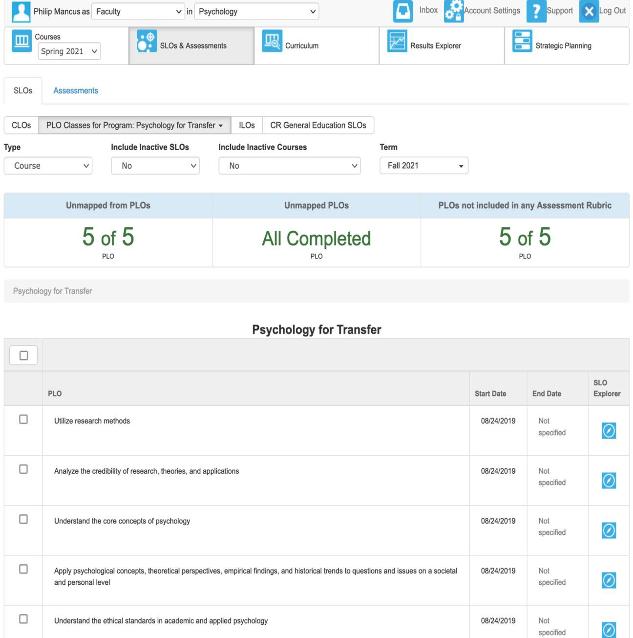

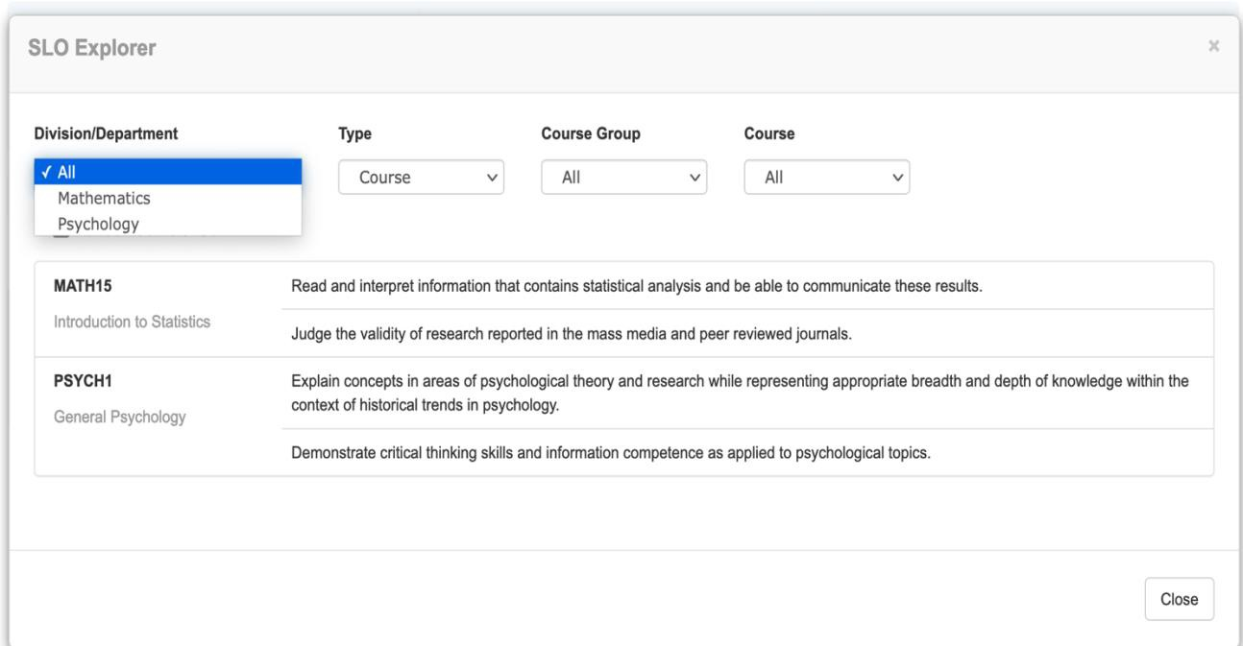

Updating the Program Outcome Map Using the Curriculum Workflow in eLumen
In the previous examples, faculty could only view the program outcome maps. Changing the maps normally requires working with your division coordinator and other program faculty. However, individual faculty members can update the program outcome map for an individual course during curriculum development, ensuring the existing CLO-PLO maps are up to date. The curriculum workflow for course outline proposals has a tab where you can inspect and change the map. This is particularly important if one or more of the outcomes are being changed, new outcomes are added, or old outcomes discontinued.
Please consult with other departmental faculty and your associate dean or program director if you plan to take this step. For more, see “Updating the Program Outcome Map in Curriculum” (Appendix C).

Program Mapping for Division and Department Coordinators
There are two ways to modify the program map in eLumen. The first involves individual faculty authors updating the map during the normal course of the curriculum workflow (see section above). The second pathway is available only to Division Coordinators within eLumen. In your role as division or department coordinator, go to “CLO & Assessments,” “Curriculum Map” subtab, and then select the program you wish to see under “Programs.” As the example below shows, you’ll see a scrollable view of all courses in a program and the selected program outcomes across the top header. The green field with a check indicates a mapped CLO to PLO. Click it to de-map that outcome alignment. Click an empty cell to map it.
Because this is a read and write view of the program map, be cautious when working in this pane to avoid errantly mapping or de-mapping an outcome. (You can ignore the “Set Attainment Levels” prompt. The college has not established this practice as of the date of this publication.) Mapping should be guided by discipline experts working in collaboration with their associate deans/directors. It is vital that the map is up to date when generating program assessment reports for the Assessment Conferences.

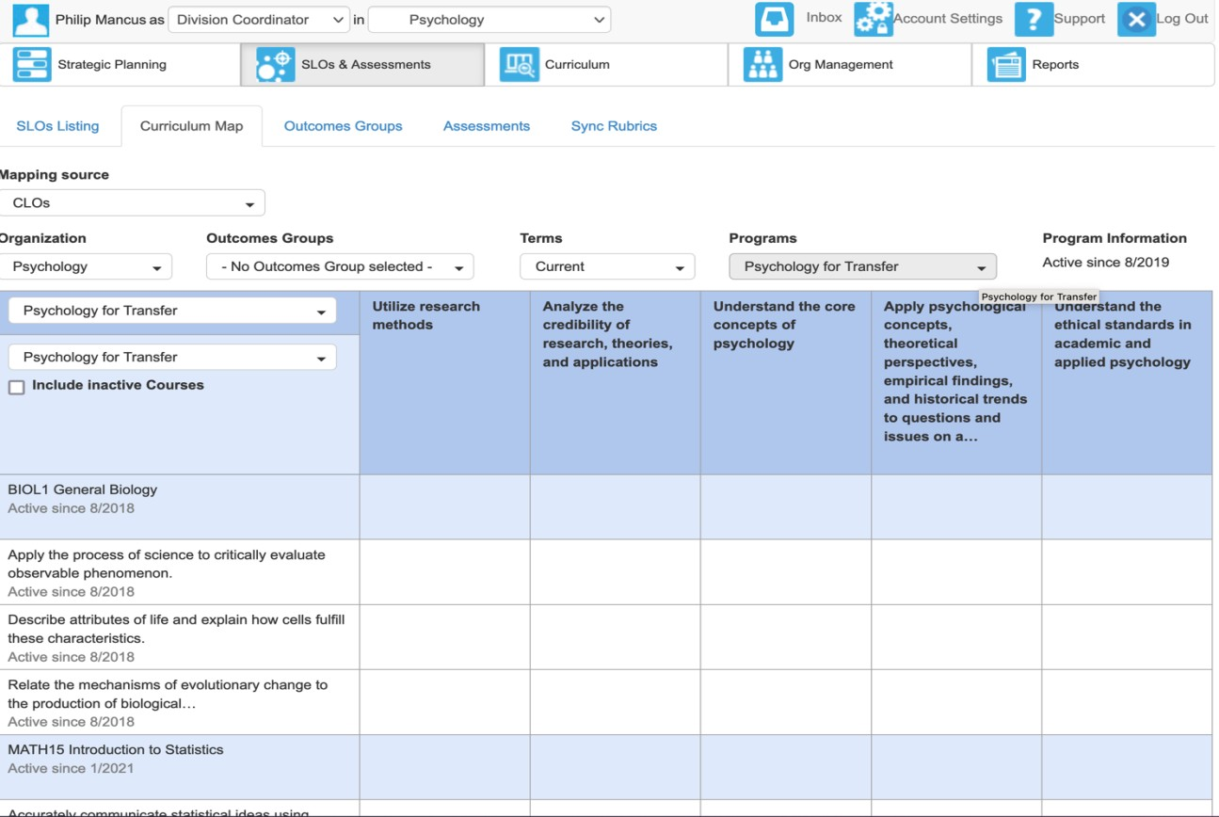

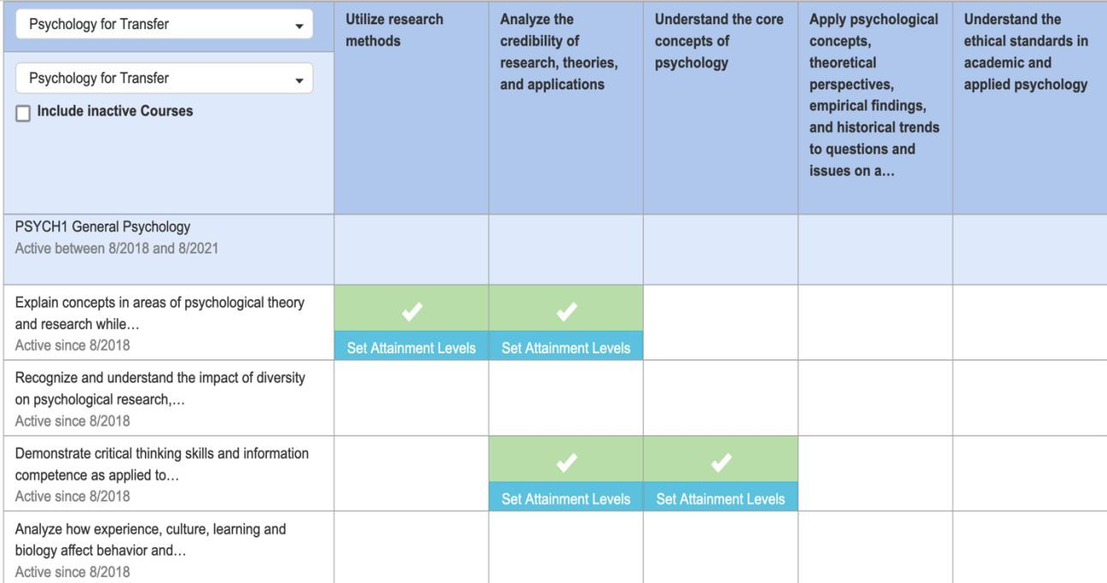

For more information, please see “Mapping Course to Program-level Outcomes” in Appendix C.

Quick Guides

Course-Level Assessment Quick Guide
Course student learning outcomes (CLOs) are defined for all classes offered at CR. CLO assessment is the foundation of the college’s internal evaluation and improvement process. Outcome assessment is required by our accrediting agency and is a faculty contractual obligation. It is vital that all faculty (part-time and full-time) understand and engage in the process.
  - At the beginning of the semester, refer to the three-year course assessment plan to see which courses are scheduled for assessment this semester. Please click the link below:
Assessment Plans, Reports, and Dialogue

  - Using the plan as a guide, division coordinators will create course assessments in the eLumen system and notify those faculty who are teaching the course that an assessment is waiting for them. Please wait until Week 12 to complete semester course assessment so the assessment most accurately reflects your final roster.

  - Assessments are accessed through each faculty’s eLumen course dashboard. A blue scorecard will be present in the third column for every course scheduled for assessment in a given semester. You can also access course assessment through your eLumen inbox. Please view the tutorial “Performing Course Assessment” available on the assessment website and in Appendix C.

  - At this time, faculty should:
    - Review the previous assessments of that course. This step is important for identifying and tracking improvement plans related to the course. You may need to access the legacy site for past CLO reports.
    - Contact other instructors teaching the same course during the same semester and briefly discuss methods of outcome assessment (test question, project, etc.). Determine if the methods will be uniform (same test question, project, etc.) or differ between sections. A listing of faculty teaching the same course can be determined using a section search on WebAdvisor

  - By the end of the semester, give your assessment activity to students. Strive to assess all students on all course outcomes in all sections you are teaching. Without data from every section taught, program level outcome assessment reports will be harder to interpret.
    - If you have already mapped your lesson planning, course objectives, and classroom activities to the course’s outcomes, you might use the assessment activities (i.e., assignments) that you would normally assign. You can score outcome mastery separately, alongside the graded assignment, provided that the assignment effectively measures the outcome.
    - When assessing student learning of an outcome, specify the performance criteria you’ll use to determine each level of mastery (did not meet, met, or exceeded expectations). You’ll use this rubric to score each student’s performance on that outcome.

  - Compile and report the results using the eLumen system. Using the “Courses” tab with the current term, locate the course scheduled for assessment, and click the blue scorecard icon in the third column. Report the number of students at each level of attainment for each outcome. Include the number of students who were not assessed on each outcome. Do this for each section of the assessed course that you are teaching.

  - Complete the Reflection Template using detailed and substantive responses. This is a very important aspect of a course assessment and plans a fundamental role for using course assessment during Program outcome assessment. If you teach more than one section of a given course, you only need to complete the Reflection Template for one section. However, you may complete a separate reflection for each section if you feel there was meaningful difference between specific sections and discussion of these differences would be beneficial for the program faculty.

Program-Level Assessment Quick Guide
Each program defines Program-level Outcomes (PLOs), the capacities that students develop by completing a program. Each PLO is “mapped” to (aligned with) CLOs from the program curriculum, so that mastery of the course outcome contributes to mastery of the program outcome. Program outcome evaluation therefore relies on assessment data from mapped CLOs for those courses making up the program (degrees and certificates). When aggregated, data from multiple courses provide a big picture narrative about program effectiveness and student learning trends. This information is used for continuous, sustainable improvement of student learning as part of the Integrated Planning process.
Program assessment is conducted according to each program’s assessment plan. During flex days prior to both the fall and spring semester, faculty from programs with outcomes scheduled for assessment will meet to engage in program outcome assessment. These sessions facilitate dialogue on course assessments and program-level outcomes, generate collaborative efforts toward program improvement, and provide documentation of ensuing discussions, and often lead to plans for Program Review. Faculty input (part-time and full-time) is critically important for meaningful program assessment. Below is a list of steps that should be followed for the successful completion of PLO assessment.

- Faculty will receive an email from the Assessment Coordinator prior to the Program Assessment flex session containing instructions on how you should prepare for this program assessment session. The email will also contain the Program Assessment Dialogue Worksheet (PADs) that will have all the courses mapped to the PLO(s) being assessed. You will want to read the Course Assessment Reports for the courses listed on the PADs document. Course Assessment reports can be found by clicking this link. You will also want to go back into your last Program Review template and review any plans that relate to the PLOs being assessed. Part of assessment is evaluated the success of prior plans. Program Review can be accessed by clicking this link. If applicable, the email will also contain a CLO performance report showing aggregate performance data for each mapped course that has been assessed within the eLumen system. The more prepared you are for these sessions, the more value they will have to your subsequent Program Review.

- You may wish to compile other data that can be used for program assessment, such as completion rates, equity data, surveys, community advisory committee input, etc. Combined with program outcome reports and course assessment reports, these are the data for the assessment conferences.

- During the program assessment dialogue session, division coordinators facilitate faculty analysis and discussion of program and course assessment reports. The team reviews assessment results and their implications for program effectiveness, identifying areas of strength and areas needing improvement, and determining what actions need to be taken to improve courses and programs.

- The end goal in completing the PADs document is to form plans your feel will help improve the program based on robust dialogue and assessment results. These plans will be included in your next Program Review process.

Student Services Assessment Quick Guide
Departments and service areas that either directly or indirectly support student success are also required to define and regularly assess outcomes to ensure programs are regularly meeting their missions. All outcomes should be assessed at least once in a three-year cylce. While outcome assessment can be conducted at any time that is appropriate to each service area, the results and dialogue are reported in Program Review. The following steps guide you through the process.
- Consult the service area assessment schedules found on the Assessment Plans, Reports, and Dialogue webpage to determine which outcome(s) are scheduled to be assessed that year. Student services assessment schedules can be found by clicking this link. Also, review your last Program Review template and identify any plans that relate to the outcome(s) being assessed. Part of the assessment process is evaluating the success of prior plans. Program Review can be accessed by clicking this link.
- Choose your service area from the menu and the outcomes appear, along with the two-year plan showing when each outcome is scheduled to be assessed. Update the plan as needed.
- Follow the steps in the Student Services Assessment Dialogue worksheet (SSADs). This worksheet, found on the Assessment website, will lead you through strategizing about how to conduct the assessment and any data collection necessary. The end goal in completing the SSADs document is to form plans your feel will help improve the program based on robust dialogue and assessment results. These plans will be included in your next Program Review process and you can use this SSADs document to establish evidence of the use of assessment for program review planning.
- Discuss and report the results of outcome assessment in Program Review. Go to https://internal.redwoods.edu and select Program Review under Faculty & Staff Resources > Processes. Log in using your credentials and select your area.
    - On the Program Indicators tab, include at least half of your area’s CLOs among the other program indicators that you normally use. Record the results from the two most recent assessments (the findings from the last assessment and the findings from the current assessment of the same outcome). Under trends and implications for program improvement, comment on any notable trends and changes seen in your outcome assessment results, including what these results may imply for program improvement. In the section on Student Equity, comment on current outcomes or initiatives related to increasing outreach, retention, and student success of under-represented students.
    - On the Critical Reflection of Assessment Activities tab, report on any changes that have been made to the program based on previous outcome assessment findings. Include any discussion on the results of those changes and their effectiveness. This is where you report on any improvement actions that have already been implemented (i.e., the assessment-driven Program Plans listed on past Program Reviews) and where you gauge their effectiveness in light of recent outcome assessment. This section documents departmental discussion on the topic.
    - On the same tab, in the next section, describe any aspects of your program that need further research, action, and/or institutional support, based on the trends and implications that you identified in your CLO assessment results on the Program Indicators tab. This is where you identify improvement actions that you will implement, including your rationale for doing so (i.e., the conclusions you made from your analysis of assessment findings). Depending on departmental needs and priorities, you will then create a program plan to carry this out.
    - On the Planning tab, include among your other program plans those assessment-derived plan(s) identified in the previous section. Under Relationship to Previous Assessment, describe how this plan is related to your review and discussion of recent CLO assessment. Under Expected Impact on Program/Student Learning, describe – in measurable terms – the change you expect to see by carrying out that plan. (Note: It is the plans on this tab that you will eventually report on in the Critical Reflection on Assessment Activities tab next time you report assessment in Program Review, thus, closing the loop.)

If your area needs consultation on any of these steps, please contact the Assessment Coordinator.

Assessment Methodology

Introduction
The 2014 ACCJC Accreditation Standards require that student learning outcomes (CLOs) be assessed at the course, program, certificate, and degree level (ACCJC Standard II.A.2.f, p. 7). In addition to these external requirements, College of the Redwoods seeks to create a culture of authentic assessment. To assist you in this goal, this section covers outcome development, assessment methods, and curriculum implementation.

Authentic Assessment
Authentic assessment focuses on what students are able to do, to produce, or to demonstrate in scenarios that are as realistic as possible. For example, if the real-world situation calls for being able to evaluate policy alternatives, the product would be an analysis that identifies the pathways and outcomes of implementing each alternative. This would likely be a team effort, working with people of various expertise.
In preparing students for such a scenario, a course (along with other program curricula) would need to be built in such a way that the process of learning the related concepts, skills, theories, and issues would contribute in some meaningful way to the ability to work with others, conduct research, organize data, analyze trends, predict behavior, project outcomes, and summarize conclusions.
When choosing an assessment method, the activity should therefore allow students to effectively demonstrate these abilities. If the learning outcomes for the course are defined with these capacities in mind, and content is geared toward outcomes, authentic assessment follows.

Defining and Measuring Student Learning Outcomes
When creating outcomes for courses and programs, focus on what students should be able to do, not what you as the individual are going to do. Ensure the outcomes can be operationally defined in the form of observed behavior, inferred attitudes, discrete knowledge, or performed skills. Aim for the culmination or synthesis of abilities that students gain as result of undergoing the learning process. Create a manageable number, depending on what is essential (a range of three to five outcomes in each course and program is common). And design your courses and programs so that all materials and activities prepare students for mastery of the outcomes.

Tips for Outcomes Development
Good student learning outcomes specify actions that are meaningful, measurable, and linked to program and institutional processes. When it comes to developing CLOs:
- Focus on outcomes, not processes. Don’t address what was taught, but rather address the observable outcome you expect to see in the student. Think about the knowledge, skills, and attitudes you expect from students who complete program activities.
- Make sure CLOs are written as outcomes rather than objectives (outcomes indicate the big picture rather than nuts and bolts associated with objectives; student learning outcomes address student competency rather than content coverage).
- Focus on the substance of the outcomes, not just the means for their expression (i.e., how they are measured). Typically, between three and five student learning outcomes for each program is sufficient.
- Use active verbs in describing student learning outcomes. Active verbs are easier to measure. For instance, if you want students to understand how to correctly use the Academic Support Center – using the word “understand” is not measurable. Instead try to imagine the outcome – students will “create” and “produce” quality resumes at the Career and Transfer Center (or describe, classify, distinguish, explain, interpret, compose, perform, demonstrate, etc.)
- For pragmatic reasons, remember that at least one means of assessment will need to be developed for each intended outcome (Nichols and Nichols, p. 20).
- How to determine whether the CLO is appropriate: Does it represent a fundamental outcome of the program? Is it the outcome, or a series of sequenced activities leading up to the outcome? Does it represent collegiate level work?
- The accomplishment of most statements of intended educational (student learning) outcomes should be ascertainable/measurable.
- “Measurable” doesn’t necessarily need to mean that it is quantifiable, precluding qualitative judgments. “Measurable” can include a general judgment of whether students know, think, and can do most of what is intended for them.
- Be careful when using attitudes to define your learning outcome (“students care for clients,” etc.), as they can be hard to assess. If the attitude is crucial to success in your program or course, ask what form of behavior it would entail.
- Criteria for meeting student learning outcomes should be reasonable yet challenging.
- Whenever feasible, set both primary (overall) and secondary (detailed) levels as benchmarks or criteria for success at the degree or program level (e.g., the average score of graduates on a standard exam will be at or near the 50th percentile and no sub-scale score will be below the 30th percentile).
- Write student learning outcomes in language that anyone reading it will understand.

Indirect vs. Direct Assessment Methods
The ideal way to assess student learning outcomes is to directly measure student performance. In some cases, the direct method is less attainable. This may be particularly true for learning and student support service areas. For some pointers, consider these examples of direct and indirect methods of assessment, adapted from Saddleback College’s “Guide to Developing and Assessing Student Learning Outcomes and Administrative/Service Unit Outcomes”.
Examples of direct methods of assessment which apply to both courses and program include:
Capstone Course Evaluation: Capstone courses integrate knowledge, concepts, and skills associated with an entire sequence of study in a program. This method of assessment is unique because the courses
themselves become the instruments for assessing student teaching and learning. Evaluation of students’ work in these courses is used as a means of assessing student outcomes. For academic units where a single capstone course is not feasible or desirable, a department may designate a small group of courses where competencies of completing majors will be measured.
Classroom Assessment: Often designed for individual faculty who wish to improve their teaching of a specific course but can also be used on the program level.
Collective Portfolios: Faculty assemble samples of student work from various classes and use the “collective” to assess specific program learning outcomes.
Commercially Produced or Standardized Tests: Commercially generated or standardized tests are used to measure student competencies under controlled conditions. Tests are developed and measured nationally to determine the level of learning that students have acquired in specific fields of study. For example, nationally standardized multiple-choice tests are widely used and assist departments in determining programmatic strengths and weaknesses when compared to other programs and national data.
Embedded Questions on Assignments or Exams: Questions related to program learning outcomes can be embedded within course assignments or exams. For example, all sections of “research methods” could include a question or set of questions relating to your program CLOs. Faculty grade the exams as usual and then copy exam questions that are linked to the program CLOs for analysis. The findings are reported as an aggregate.
Locally Developed Exit Exams: Faculty can create an objective exam for graduating students that is aligned with the program CLOs. Performance expectations should be delineated prior to obtaining results.
Pre-Test/Post-Test Evaluations: Pre-test/post-test assessment is a method used by academic units where locally developed tests and examinations are administered at the beginning and at the end of courses or academic programs. These test results enable faculty to monitor student progression and learning throughout prescribed periods of time. The results are often useful for determining where skills and knowledge deficiencies exist and most frequently develop.
Observations: Observations of any behavior such as student presentations or students working in the library can be used for assessment. Observations can be recorded as a narrative or in a highly structured format, such as a checklist, and they should be focused on specific course and program CLOs.
Scoring Rubrics: Rubrics can be used to score any product or performance such as essays, portfolios, recitals, oral exams, etc. A detailed scoring rubric that delineates criteria used to discriminate among levels is developed and used for scoring. To enhance reliability, two raters can be used to review each product and a third rater is used to resolve discrepancies.
Transfer Records: For community colleges, the data on transfer student success in upper division courses is extremely valuable. Cal-PASS, a system of data sharing between all the systems of education in California, may be helpful.
Videotape or Audiotape Evaluations: Videotapes and audiotapes have been used by faculty as a kind of pre-test/post-test assessment of student skills and knowledge. Disciplines, such as theatre, music, art, and communication, which have experienced difficulty in using some of the other assessment methods have had significant success in utilizing videotapes and audiotapes as assessment tools.

Examples of indirect methods of assessment include:
Alumni Surveys: Surveying alumni is a useful assessment tool for generating data about student preparation for professional work, program satisfaction, and curriculum relevancy. As an assessment supplement, alumni surveying provides departments with a variety of information that can highlight completer data.
Employer Surveys: Employer surveys can provide information about the curriculum, programs, and students that other forms of assessment cannot produce. Through surveys, departments traditionally seek employer satisfaction levels with the abilities and skills of recent graduates. Employers also assess programmatic characteristics by addressing the success of students in a continuously evolving job market.
External Reviewers: Peer review of academic programs is a widely accepted method for assessing curricular sequences, course development and delivery, and the effectiveness of faculty. Using external reviewers is a useful way of analyzing whether student achievement correlates appropriately with departmental goals and objectives.
Student Exit Interviews/Surveys: Students leaving the college are interviewed or surveyed to obtain feedback. Data obtained can address strengths and weaknesses of the program and/or assess relevant concepts, theories or skills.

Qualitative vs. Quantitative Assessment Methods
Data collected through assessment activities should be both qualitative and quantitative. Quantitative data consists of numbers (or observations that can be converted to numbers); whereas Qualitative data takes the form of words and are generally reported as a narrative. For quantitative data, the same information is usually collected from each participant in exactly the same way, and different responses are translated into a series of numbers. Qualitative data emphasize flexibility in data collection and focuses on understanding themes, trends, processes, and events, rather than precisely quantifying measurements. Quantitative data are generally assumed to be more objective, whereas qualitative data might provide greater detail about specific cases. Each type has unique advantages; using a combination of both can provide a more robust snapshot of student learning.
These distinctions can easily be seen in questionnaires that use a closed-ended scale (quantitative) versus open ended text-based questions (qualitative).
Closed-ended questions limit the responses a person can make. They often use either a number scale in the question, or answers that may be converted to numbers (although quantifying some closed-ended questions would be meaningless except for coding purposes, as in the example “What is your favorite color: Red, Orange, Yellow, Green, Blue, Indigo, or Violet?”). Depending on the scale, results from closed- ended questions can be reported as average scores on each question (including standard deviations or a range of scores to help reviewers to get a more complete picture), and these results can easily be presented in tables and graphs.
Example of a closed-ended question:
How well did your program prepare you for a career in early childhood education? (Circle one number on the scale below.)
Not at all Somewhat Moderately A great deal 0 1 2 3
Open-ended questions allow people to give any answer they wish and to go into greater detail, but they are more difficult to analyze and report objectively (although computer analysis programs are becoming available for qualitative data). Typically, for open-ended questions answers can be described in a narrative. The prevalence or similarity of themes can then be detected (preferably by multiple raters) and, if desired, reported along with the relative frequency such themes occur (bridging qualitative and quantitative approaches). It is usually not as helpful (even though readers often find it interesting) to report all responses verbatim. It is better to summarize and analyze themes and trends in the data, rather than having reviewers try to interpret the meaning of a long list of open-ended survey comments.
Here's an example of an open-ended question:
Describe how your program prepared you for a career in forestry.

More About Qualitative Assessment
Qualitative assessment is a legitimate form of assessment, which should be seriously considered in any departmental decision regarding the choice of means of assessment. In fact, even when using a rubric, the expert’s evaluation is part of the decision as to whether and to what extent student learning has occurred. Qualitative means of assessment are descriptive and as such lend themselves to developing a holistic picture of student learning, based on observable, documentable criteria. Some examples include portfolio reviews, public performances, or oral examinations.
Some challenges of qualitative assessment include:
- It often involves a greater effort to identify specific, concrete criteria and standards for success.
- Unless external evaluators are used, those conducting the evaluations are frequently the same faculty who taught the students, increasing the risk of confirmation bias.
- Inter-rater reliability may be inconsistent over time, which can only be solved through thorough training of evaluators and the norming of identical procedures that are used each time the assessment is run.
Remember, in the final analysis, you are the discipline or service area expert who determines the criteria for mastering a learning outcome and who evaluates performance on that outcome. Your judgment matters.
Adapted from Oakland University Guidelines for Assessment

Scoring Outcomes
Once you’ve determined the outcomes, provided learning opportunities to students, and given an activity that measures student mastery of those outcomes, you need to establish performance criteria to score each student’s submission (which can be organized in a rubric, checklist, Likert scale, etc.). College of the Redwoods uses a three-tiered scale in defining successful achievement of an outcome. These are “Did not meet expectations,” “Met expectations,” and “Exceeded expectations.” Determine a metric that establishes the threshold for student performance at each level and that applies equally to all students. When finished with scoring, you will report the results using the same three levels. Record the number of students per section who exceeded expectations, the number who met expectations, and the number who did not meet expectations on the outcome. Be sure to also include students who were not assessed to give a fuller picture of student performance as a whole and to reflect on what the results mean for student learning.

Student Learning Outcomes and Curriculum Design
“If learning means engaging in a task that builds personal capacity for the rest of life, then curriculum design doesn’t begin in the classroom at all. Curriculum design begins outside the classroom with one important question: ‘What do my students need to be able to DO “out there” (in the rest of life) that we are responsible for in this classroom?’” (Stiehl and Lewchuk, 2002).

Designing Backwards from the Outside In
As discipline experts, faculty understand the basic facts, concepts, issues, themes, and skills that students need to learn in order to successfully master the content and specific competencies related to a course. In addition, faculty have a big picture view of how courses fit into programs. This includes defining what students will be able to accomplish after completing a course or a program. Course and program outcomes are therefore not extraneous to curriculum design, they are the culmination of what curriculum design is for.
Student learning outcome assessment depends on integrated, learner-centered course design. As content experts, we often focus on what students need to know to learn the content. In Bloom’s taxonomy, this is remembering. In addition, becoming an adaptive learner requires understanding the concepts, skills, issues, and themes of the course, being able to apply them to novel contexts, and demonstrating the ability to analyze, evaluate, and create in real world scenarios. The philosophy of learner-centered course design prepares students for the situations and problems they are likely to face after they take our classes. By working backwards from the course’s outcomes to the themes, issues, skills, and concepts that lead up to those outcomes, course design culminates in these capacities. Even if students forget some of the content, they’ll still have these newly developed abilities.
In designing a course, it is often helpful to start from the final outcomes of a course and work backwards to the specific skills, concepts, and issues related to the course. Four essential questions guide the process.
- What will the student be able to do “out there?”
- How will the outcomes be demonstrated “in here?”
- What skills will be learned in this course?
- What concepts and issues need to be understood.
For example, a student completing a course in basic information technology might need to be able to work with a team, analyze data, and create documents that communicate essential information on ways organizations can efficiently employ network solutions. Starting with these outcomes, the expert faculty would then determine the assessment activities students will need to complete in order to demonstrate achievement of these outcomes. Such tasks might include a group portfolio where students develop camera ready business documents and a multimedia presentation that summarizes relevant information for a local business.
Working backwards one step further, the faculty determine that a successful portfolio requires that students develop a range of skills, such as conducting data analysis, applying visual design principles, working with operating systems, mapping an organization’s structure and process, and effectively communicating with team members. And the foundation for these skills, in turn, are concepts such as data, analysis, layout, formatting, database, file management, network, role, structure, process, etc. Each of these levels of integrated course design needs to be addressed in the development of meaningful learning outcomes.
Ultimately, whether you start with content or with outcomes, the result should be the same: course design that links meaningful student learning outcomes to day-to-day course activities.

Formative and Summative Assessment
It’s important to distinguish between formative and summative assessment. Formative assessment occurs continuously throughout a course’s learning activities to see what progress is being made. As such, it is an important part of supporting student learning. Evaluation is not the intent; rather, it is for both the instructor and the student to track the student’s progress. Formative assessment provides immediate feedback as scaffolding to assist student understanding of what they know and did right, what they need to know, and what they need to do to learn further. This often occurs in parallel with course activities throughout the semester and is designed to monitor the process of building the knowledge and skills needed to meet course learning outcomes.
Summative assessment, in contrast, measures the student's development of capacities that apply to a variety of novel contexts outside of the classroom upon completion of the course or program requirements. While formative assessment is considered good practice and is encouraged, Student Learning Outcome assessment at College of the Redwoods is summative assessment.
Typically, outcome assessment is conducted by assigning some assignment that requires completion of the entire course before being able to succeed on the assignment (essay question, portfolio, demonstration, etc.). However, it may happen that a student would be able to meet one of a course’s outcomes upon completion of a subsection of the course, such as after a prominent learning unit. In this scenario, a capstone assignment in that unit could hypothetically serve as the summative CLO assessment activity for the related outcome. This would be one way to strategically distribute CLO assessments over the semester.
No institution or department has the resources or time to continually assess all possible aspects of each program. Given this limitation, priorities for the assessment effort must be set to avoid measuring the meaningless. Hence, it is logical to focus the department’s assessment efforts on those expectations for all students based on discipline expertise.

Using Assessment Results in Decision-Making
Assessment results can help improve programs and services. For assessment results to be useful in improving instructional programs, effective analysis and discussion of the results is needed, followed by communication, implementation, and reassessment. As part of this larger integrated planning process, CLO assessment contributes directly to program outcome assessment, which leading directly to Program Review, which then informs other institutional activities. Program reviews should reflect assessment results and include assessment-driven plans for future assessment. This relationship is shown graphically, below.

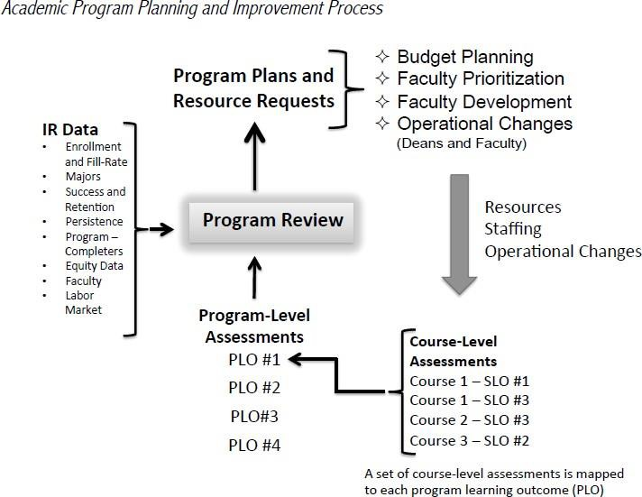

When designing courses, outcomes, activities, and programs, keep in mind how assessment results will be used in program improvement and institutional planning. Assessment results may be used simply to improve the means of assessment or to improve the student learning outcomes themselves. Assessment results may be used to change or improve a program through a closer alignment of course offerings with the requirements of the work world, or a restructuring of course sequencing. Results can lead to program or faculty development. Hence the importance of ensuring that the creation and impact of program plans is informed by continuous assessment.
At the course level, assessment results signal how well students are learning. Using these results to improve student learning can take a variety of forms. Whatever means you devise, reassessing outcomes helps to determine the effectiveness of your changes and continues the cycle of continuous improvement. Methods of improving student learning at the course level might include:
- Revising activities leading up to and/or supporting assignment and assessments,
- Increasing guidance for students as they work on assignments,
- Revising the amount of writing, oral/visual/clinical or similar work,
- Stating goals or objectives of assignment/activity more explicitly,
- Stating criteria for grading more explicitly,
- Employing different/revised teaching methods,
- Increasing/improving in-class discussions and activities,
- Increasing/improving student collaboration and/or peer review,
- Providing more frequent and/or more effective feedback on student progress,
- Encouraging more interaction with students outside of class,
- Seeking out collegial feedback on assignments/activities.

For illustration, the table below shows examples of prioritized actions to improve student learning, created through outcome assessment.

ANTH-3  Introduction to Cultural Anthropology | - Provide clearer and more repetitive explanations of how to respond to essay questions.  - Review important concepts following their initial presentation.  - Include more varied instructional modes, including non-lecture-based methods.
ART-2  Introduction to Art | - Continue to incorporate digital technologies such as Google docs, YouTube, and Art Stor.  - Encourage student knowledge of historical and contemporary art trends by assigning student research presentations on course related topics.  - Tour students around the Creative Art facilities. This extra effort encourages students to engage deeply in their material and in our discipline.
BIOL-3  Cell Biology | - Require course to be taken earlier in the program sequence.

FNR-31  Introduction to Geospatial Concepts | - Adapt to online instruction by changing final project requirements.
GS-1  College Success | - Require students to meet with advisors and develop education plans.
PSYCH-1  General Psychology | - Meet regularly with other faculty to share successful teaching methods.
SOC-1  Introduction to Sociology | - Provide additional reading and spend more time discussing and applying core concepts.  - Address the affective domain of learning by having students reflect on and write about how the course material directly applies to their personal life.

Student Support Services Assessment

Regarding student services assessment at CR, ACCJC Standard II, “Student Learning Programs and Support Services,” specifies that:
The institution identifies and assesses learning support outcomes for its student population and provides appropriate student support services and programs to achieve those outcomes. The institution uses assessment data to continuously improve student support programs and services. (Standards
II.C. 1 & 2)
Regular outcome assessment allows student service areas to determine how effective they are and to find ways to improve service delivery.

Student Learning Outcomes in Student Support Services
How does outcome assessment apply to student support services? The term Student Learning Outcome describes what students will be able to think (attitudinal), know(cognitive), or do (behavioral) when they’ve completed a given educational program and/or service. The ACCJC has adopted the term Learning Support Outcome to refer to how learning support and student support programs and services help students meet learning outcomes and succeed in their educational endeavors. CR also uses the term “Service Area Outcome” when defining what a service area must accomplish to achieve its mission, even if this does not directly result in or can be measured as knowledge gained by students. While the relevance of each term depends on what the service does, all areas define and assess outcomes, ideally using data collected from students. And despite these fine distinctions, we will refer to these as student services outcomes, or SSOs.
Almost every CR student, no matter how many classes they take, must apply for admission, seek counseling and advising, go through assessment testing and orientation, obtain course materials, discuss career and transfer issues, apply for financial aid, and pay fees. Students rely on these services to continue their study, and these interactions influence their learning experiences. Consider whether students would be able to attain the desired level of education without these support programs and services.
When formulating or updating service SSOs, try to determine what the core functions of your student services area are. What do your student services area need to accomplish to meet the mission and goals of the college? What do students need from your service area to successfully complete their educational goals?

References
Academic Senate for California Community Colleges. (2019). Student Learning Outcomes.
Allen, Mary. “Articulating Learning Objectives”. Workshop presented at WASC/AAHE Collaborative Workshop on Building Learner-Centered Institutions-Developing Institutional Strategies for Assessing and Improving Student Learning. March 2004. Association for Supervision and Curriculum Development (ASCD) http://www.ascd.org/portal/site/ascd/menuitem.5a47c86b3b7b44128716b710e3108a0c/
Angelo, T. (1995). “Improving Classroom Assessment to Improve Learning.” Assessment Update,7(6), 1-2, 13-14.
Astin, A. W., Banta, T. W., Cross, K. P., El-Khawas, E., Ewell, P. T., Hutchings, P., & Moran, E.(1992). “Principles of good practice for assessing student learning.” AAHE Bulletin, 45(4).
California State University Sacramento. (2004). Assessment Glossary of Terms http://www/csus.edu/acaf/Portfolios/GE/glossary.htm
Ewell, P.T. (1991). “To Capture the Ineffable: New Forms of Assessment in Higher Education.” In G.Grant (ed.), Review of research in Education, no. 17, Washington, DC: American EducationalResearch Association.
Luan, Jing. “Pragmatic Assessment of Student Services in Community Colleges” iJournal: Insight Into Student Services, No. 4, March 2003
Lyons, N. “Portfolios and Their Consequences: Developing as a Reflective Practitioner” In N. Lyons(ed.),
With Portfolio in Hand: Validating the New Teacher Professionalism, New York: Teacher’s College Press. New Horizons for Learning. http://www.newhorizons.org
Nichols J & Nichols K. (2000). The Departmental Guide and Record Book for Student Outcomes Assessment and Institutional Effectiveness. NY: Agathon Press.
Palomba, C & Banta T. (1999). Assessment Essentials: Planning, Implementing, and ImprovingAssessment in Higher Education. San Francisco: Jossey Bass
Stiehl, R. E., & Lewchuk, L. (2002). The Outcomes Primer: Reconstructing the College Curriculum.
Learning Organization.
Walvoord, B. and Anderson V.J., (1998) Effective Grading: A Tool for Learning and Assessment. San Francisco: Jossey Bass.

Appendix A: Glossary of Assessment Terms

Accountability
The obligation placed on an educational institute by public officials, employers, and taxpayers for school officials to demonstrate that money invested in education has led to measurable learning. Accountability is often viewed as an important factor in education reform. An assessment system connected to accountability can help identify needs so that resources can be equitably distributed.

Accreditation
Official recognition that an institution meets required standards established by an accreditation body authorized to operate by the U.S. Department of Education. College of the Redwoods is accredited by the Accrediting Commission for Community and Junior Colleges (ACCJC).

Achievement Test
A standardized test designed to efficiently measure the amount of knowledge and/or skill a person has acquired, usually as a result of classroom instruction. Such testing produces a statistical profile used as a measurement to evaluate student learning in comparison with a standard or norm.

Affective
The affective domain describes learning objectives that emphasize a feeling tone, an emotion, or a degree of acceptance or rejection. Affective objectives vary from simple attention to selected phenomena to complex but internally consistent qualities of character and conscience. They include concepts being undertaken, gained or realized through an active process of engagement with some problem or experiment. Students are encouraged to not just receive information at the bottom of the affective hierarchy. We’d like students to respond to what they learn, to value it, to organize it and maybe even to characterize themselves as students or professionals in their fields of study.

Alternative Assessment
Alternatives to traditional, standardized, norm- or criterion-referenced traditional paper and pencil testing. An alternative assessment might require students to answer an open-ended question, work out a solution to a problem, demonstrate a skill, or produce work rather than multiple choice questions. Portfolios and instructor observation of students are alternative forms of assessment.

Analytic Scoring
A type of rubric scoring that separates the whole into categories of criteria that are examined one at a time. Student writing, for example, might be scored on the basis of grammar, organization, and clarity of ideas. Useful as a diagnostic tool. An analytic scale is useful when there are several dimensions on which the work will be evaluated. (See Rubric.)

Aptitude Test
A test intended to measure the test-taker’s innate ability to learn; given before receiving instruction.

Artifact
A sample of student work that is scored according to an established rubric for assessment purposes.

Assessment
Assessment is the cycle of analyzing data and evaluating the results to inform improvements to the teaching and learning process, aimed at understanding and improving student learning. It involves making our expectations explicit and public; setting appropriate criteria and standards for learning quality; systematically gathering, analyzing, and interpreting evidence to determine how well performance matches those expectations and standards, and using the resulting information to document, explain and improve performance (Angelo, 1995).

Assessment Literacy
The possession of knowledge about the basic principles of sound assessment practice, including terminology, the development and use of assessment methodologies and techniques, familiarity with standards of quality in assessment. Increasingly, familiarity with alternatives to traditional measurements of learning.

Assessment Task
An illustrative task or performance opportunity that closely targets defined instructional aims, allowing students to demonstrate their progress and capabilities.

Benchmark
Student performance standards: the level(s) of student competence in a content area. An actual measurement of group performance against an established standard at defined points along the path toward the standard. Subsequent measurements of group performance use benchmarks to measure progress toward achievement.

Bloom’s Taxonomy of Cognitive Objectives
Benjamin Bloom originated this taxonomy for categorizing the level of abstraction of questions that commonly occur in educational settings. The taxonomy provides a useful structure in which to categorize test questions, since instructors will characteristically ask questions within particular levels. There are six levels arranged in order of increasing complexity (1=low, 6=high). Each one is below (along with the updated terminology).
- Knowledge (Remembering): Recalling or remembering information without necessarily understanding it. Includes activities such as describing, listing, identifying, and labeling.
- Comprehension (Understanding): Grasping the meaning of learned material. Includes the ability to convey, explain, discuss, and interpret.
- Application (Applying): Putting ideas and concepts to work in solving problems. Includes demonstrating, utilizing, implementing, and showing.
- Analysis (Analyzing): Breaking down information into its component parts to see interrelationships and ideas. Includes differentiating, sorting, comparing, and categorizing.
- Evaluation (Evaluating): Judging the value of evidence or performance based on definite criteria. Includes gauging, rating, ranking, concluding, criticizing, and recommending.
- Synthesis (creating): Combining parts and forming wholes to make something original. Includes:
producing, transforming, constructing, unifying.
For a more detailed list of verbs in Bloom’s Taxonomy, see Appendix B

Capstone Assessment
Assessment activities occurring at the end of a course or program, demonstrating outcome mastery through some product or performance. The outcomes may be those of the major and of the general education program or of the major only (Palomba & Banta, 1999).

Cohort
A group whose progress is followed by means of measurements at different points in time.

Concept
An abstract, general notion; a heading that characterizes a set of behaviors and/or beliefs.

Continuous Improvement
Continuous improvement involves an on-going, cyclical process of identifying evidence and implementing incremental changes to improve student learning.

Course Assessment
The process in which faculty evaluate curriculum by collecting student learning outcome data aimed at measuring successful learning in an individual course and improving instruction with a goal of enhancing learning.

Course Assessment Report
A report generated in eLumen showing assessment results and faculty reflections for a particular course.

Course-level Student Learning Outcomes (CLOs)
The Student Learning Outcome (CLOs) for a particular course. These are defined in the official Course Outline of Record.

Criteria/Standards
Performance descriptors indicate how well students have met expectations of what they should be able to think, know or do. They are descriptive benchmarks against which performance is judged. These criteria or standards may be described in varying gradients of success as in rubrics or in grades. Often, they are stated in terms of percentages, percentiles or other quantitative measures (Nichols, 2000).

Direct Assessment Methods
These methods involve students’ display of knowledge and skills (e.g., text results, written assignments, presentations, classroom assignments) resulting from learning experience in the class/program (Palomba & Banta, 1999).

eLumen
This is the software platform where assessment data is managed.

Semester Assessment Conferences
The period of time each semester when outcome assessment is reviewed, discussed, and used to evaluate and improve curriculum, instruction, and student learning.

Formative Assessment
Assessment conducted during a performance/course/program with the purpose of providing feedback that can be used to modify, shape, and improve a performance/course/program (Palomba & Banta, 1999).

General Education Student Learning Outcomes (GEOs)
General education outcomes are the knowledge, skills, and abilities a student is expected to be able to demonstrate following a program of courses designed to provide the student with a common core of knowledge consistent with that of a liberally educated or literate citizen.

Indirect Assessment Methods
Assessment methods that involve perceptions of learning rather than actual demonstrations of outcome achievement (e.g., alumni surveys, employer surveys, exit interviews).

Institutional Learning Outcomes (ILOs)
Institutional learning outcomes are the knowledge, skills, and abilities with which a student is expected to leave an institution as a result of a student’s total educational experience.

Measurement
Quantitative description of student learning and qualitative description of student attitude.

Metacognition
The knowledge of one’s own thinking processes and strategies, and the ability to consciously reflect and act on the knowledge of cognition to modify those processes and strategies.

Mission
A holistic vision of the values and philosophy of a department, program, unit or institution (Palomba& Banta, 1999; Allen, 2004).

Multidimensional Assessment
Assessment that gathers information about a broad spectrum of abilities and skills.

On-Demand Assessment
An assessment process that takes place as a scheduled event outside the normal routine. An attempt to summarize what students have learned that is not embedded in classroom activity.

Outcomes
An operationally defined educational goal, usually a culminating activity, product, or performance that can be measured.

Performance-Based Assessment
Direct, systematic observation and rating of student performance of an educational objective, often an ongoing observation over a period of time, and typically involving the creation of products. Performance-

based assessment is a test of the ability to apply knowledge in a real-life setting. It is also the performance of exemplary tasks in the demonstration of intellectual ability. Evaluation of the product of a learning experience can also be used to evaluate the effectiveness of teaching methods.

Performance Criteria
The standards by which student performance is evaluated. Performance criteria help assessors maintain objectivity and provide students with important information about expectations, giving them a target or goal to strive for.

Portfolio
A systematic and organized collection of a student’s work that exhibits to others the direct evidence of a student’s efforts, achievements, and progress over a period of time. The collection should involve the student in selection of its contents, and should include information about the performance criteria, the rubric or criteria for judging merit, and evidence of student self-reflection or evaluation. It should include representative work, providing documentation of the learner’s performance and a basis for evaluation of the student’s progress. Portfolios may include a variety of demonstrations of learning and have been gathered in the form of a physical collection of materials, videos, digital files, reflective journals, etc.

Program Assessment
The process in which faculty evaluate program effectiveness by analyzing course assessment data and other indicators of student learning and program performance.

Program Assessment Report
A report generated in eLumen showing assessment results as they pertain to program-level outcomes.
Also known as "CLO Performance Report."

Program Assessment Dialogue Sessions
Specific meetings during the Fall and Spring Assessment Conferences where program faculty convene to discuss assessment and evaluate program effectiveness.

Program-level Outcomes
These are the higher-order abilities that students gain as they progress through and successfully complete a program.

Program Outcome Map
The grid that shows which CLOs map to specific PLOs.

Program Plan
A specific plan of action itemized in Program Review. Improvement plans resulting from program assessment dialogue should be included among your program plans.

Qualitative Methods of Assessment
Methods that rely on descriptions rather than numbers. Examples: Ethnographic field studies, logs, journals, participant observation, and open-ended questions on interviews and surveys.

Quantitative Methods of Assessment
Methods that rely on numerical scores or ratings. Examples: Surveys, Inventories,
Institutional/departmental data, departmental/course-level exams (locally constructed, standardized, etc.).

Rating Scale
A scale based on descriptive words or phrases that indicate performance levels. Qualities of a performance are described (e.g., advanced, intermediate, novice) in order to designate a level of achievement. The scale may be used with rubrics or descriptions of each level of performance.

Reliability
The measure of consistency for an assessment instrument. The instrument should yield similar results over time with similar populations in similar circumstances.

Rubric
In general, a rubric is a scoring guide used in subjective assessments. A rubric implies that a rule defining the criteria of an assessment system is followed in evaluation. A rubric can be an explicit description of performance characteristics corresponding to a point on a rating scale. A scoring rubric makes explicit expected qualities of performance on a rating scale or the definition of a single scoring point on a scale.

Scale
A classification tool or counting system designed to indicate and measure the degree to which an event or behavior has occurred.

Self-Assessment
A process in which a student engages in a systematic review of their performance, usually for the purpose of improving future performance. May involve comparison with standard, established criteria. May involve critiquing one’s own work or may be a simple description of the performance.

Standards
Agreed upon values used to measure the quality of student performance, instructional methods, curriculum, etc.

Student Learning Outcome (CLO)
The specific observable or measurable results that are expected subsequent to a learning experience. CLOs describe a student’s ability to synthesize many discreet skills using higher level thinking and to produce something that requires application of what has been learned.

Summative Assessment
A summative assessment is a final determination of knowledge, skills, and abilities. Such an assessment can be exemplified by exit or licensing exams, capstone projects, or any evaluation that is not created to provide feedback for improvement but rather is used for final judgments.

Appendix B: Bloom’s Taxonomy

Knowledge (Remember) | Comprehension (Understand) | Application (Apply) | Analysis (Analyze) | Synthesis (Create) | Evaluation (Evaluate)
Count Define Describe Draw Label List Match Name Outline Point Quote Read Recall Recite  Recognize Record Repeat Reproduce Select State Write Memorize Arrange Duplicate Order Relate Tabulate | Associate Classify Compute Contrast Convert Defend Describe Differentiate Discuss Distinguish Estimate Explain Extend Extrapolate Generalize Give examples Infer  Identify Indicate Interpret Locate Paraphrase Predict Report Restate Review Rewrite Translate | Add Calculate Change Choose Classify Complete Compute Demonstrate Discover Divide Employ Examine Experiment Graph Interpolate Manipulate Modify Operate Perform Practice Prepare Produce Relate Research Organize Schedule Service Show Sketch Solve Subtract Translate  Troubleshoot  Write | Analyze Application Appraise Breakdown Calculate Categorize Combine Compare Connect Contrast Criticize Design Detect Diagram Differentiate Discriminate Distinguish Examine Experiment Explain Infer  Outline Point out Question Relate Select Separate Subdivide Test Utilize | Arrange Assemble Categorize Collect Combine Compile Compose Construct Create Design Develop Devise Drive Explain Formulate Generalize Generate Group Integrate Invent Formulate Modify Order Organize Plan Prepare Propose Rearrange Reconstruct Reorganize Revise Rewrite Specify Summarize  Transform | Appraise Arbitrate Argue Assess Attach Award Choose Compare Conclude Contrast Convince Critique Decide Defend Determine Discriminate Evaluate Explain Grade Interpret Judge Justify Measure Predict Prioritize Rank  Rate Recommend Referee Reject Select Support Test  Value

Cognitive Domain
Category | Examples and Key Words
Knowledge: Recall data or information. | Examples: Recites a policy. Quotes prices from memory to a customer. Knows the safety rules.  Key Words: defines, describes, identifies, knows, labels, lists, matches, names, outlines, recalls, recognizes, reproduces, selects, states.
Comprehension: Understand the meaning, translation, interpolation, and interpretation of instructions and problems.  State a problem in one’s own words. | Examples: Rewrites the principles of test writing. Explain in one’s own words the steps for performing a complex task. Translates an equation into a computer spreadsheet.  Key Words: comprehends, converts, defends, distinguishes, estimates, explains, extends, generalizes, gives examples, infers, interprets, paraphrases, predicts, rewrites, summarizes, translate.
Application: Use a concept in a new situation or unprompted use of an abstraction. Applies what was learned in the classroom into novel situations in the workplace. | Examples: Uses a manual to calculate an employee’s vacation time. Applies laws of statistics to evaluate the reliability of a written test.  Key Words: applies, changes, computes, constructs, demonstrates, discovers, manipulates, modifies, operates, predicts, prepares, produces, relates, shows, solves, uses.
Analysis: Separates material or concepts into component parts so that its organizational structure may be understood.  Distinguishes between facts and inferences. | Examples: Troubleshoots a piece of equipment by using logical deduction. Recognize logical fallacies in reasoning. Gathers information from a department and selects the required tasks for training.  Key Words: analyzes, breaks down, compares, contrasts, diagrams, deconstructs, differentiates, discriminates, distinguishes, identifies, illustrates, infers, outlines, relates, selects, separates.
Synthesis: Builds a structure or pattern from diverse elements. Put parts together to form a whole, with emphasis on creating a new meaning or structure. | Examples: Writes a company operations or process manual. Designs a machine to perform a specific task. Integrates training from several sources to solve a problem. Revises and processes to improve the outcome.  Key Words: categorizes, combines, compiles, composes, creates, devises, designs, explains, generates, modifies, organizes, plans, rearranges, reconstructs, relates, reorganizes, revises, rewrites, summarizes, tells, writes.
Evaluation: Makes judgments about the value of ideas or materials. | Examples: Selects the most effective solution. Hires the most qualified candidate. Explains and justifies a new budget.  Key Words: appraises, compares, concludes, contrasts, criticizes, critiques, defends, describes, discriminates, evaluates, explains, interprets, justifies, relates, supports.

Affective Domain
Category | Examples and Key Words
Receiving Phenomena: Demonstrates awareness, willingness to hear, selected attention. | Examples: Listens to others with respect. Listen for and remember the names of newly introduced people.  Key Words: asks, chooses, describes, follows, gives, holds, identifies, locates, names, points to, selects, sits, erects, replies, uses.
Responding to Phenomena: Active participation on the part of a learner. Attends and reacts to a particular phenomenon. | Examples: Participates in class discussions. Gives a presentation. Questions new ideas, concepts, models, etc.in order to fully understand them. Knows the safety rules and practices them. Learning outcomes may emphasize compliance in responding, willingness to respond, or satisfaction in responding (motivation).  Key Words: answers, assists, aids, complies, conforms, discusses, greets, helps, labels, performs, practices, presents, reads, recites, reports, selects, tells, writes.
Valuing: The worth or value a person attaches to a particular object, phenomenon, or behavior. Ranges from simple acceptance to the more complex state of commitment. Based on the internalization of a set of specified values, while clues to these values are expressed in the learners’ overt behavior. | Examples: Demonstrates belief in the democratic process. Is sensitive towards individual and cultural differences (value diversity). Shows the ability to solve problems. Proposes a plan for social improvement and follows through with commitment. Informs management on matters that one feels strongly about.  Key Words: completes, demonstrates, differentiates, explains, follows, forms, initiates, invites, joins, justifies, proposes, reads, reports, selects, shares, studies, works.
Organization: Organizes values into priorities by contrasting different values, resolving conflicts between them, and creating a unique value system. Emphasis on comparing, relating, and synthesizing values. | Examples: Balances freedom and responsibility. Accepts responsibility for behavior. Explains the role of systematic planning in solving problems. Accepts professional ethical standards. Creates a life plan in harmony with abilities, interests, and beliefs. Prioritizes time effectively to meet the needs of the organization, family, and self.  Key Words: adheres, alters, arranges, combines, compares, completes, defends, explains, formulates, generalizes, identifies, integrates, modifies, orders, organizes, prepares, relates, synthesizes.

Characterization: Has a value system that controls behavior, one that is pervasive, consistent, predictable, and characteristic of the learner. Shows a general pattern of adjustment (personal, social, emotional). | Examples: Shows self-reliance when working independently. Cooperates in group activities (displays teamwork). Uses an objective approach in problem solving. Displays a professional commitment to ethical practice on a daily basis. Revises judgments and changes behavior in light of new evidence. Values people for what they are, not how they look.  Key Words: acts, discriminates, displays, influences, listens, modifies, performs, practices, proposes, qualifies, questions, revises, serves, solves, verifies.

Psychomotor Domain
Category | Examples and Key Words
Perception: The ability to use sensory cues to guide motor activity. This ranges from sensory stimulation, through cue selection, to translation. | Examples: Detects non-verbal communication cues. Estimate where a ball will land after it is thrown and then moving to the correct location to catch the ball. Adjusts heat of stove to correct temperature by smell and taste of food. Adjusts the height of the forks on a forklift by comparing where the forks are in relation to the pallet.  Key Words: chooses, describes, detects, differentiates, distinguishes, identifies, isolates, relates, selects.
Set: Readiness to act. Includes mental, physical, and emotional sets: dispositions that predetermine a person’s response to different situations (sometimes called mindsets). | Examples: Knows and acts upon a sequence of steps in a manufacturing process. Recognize one’s abilities and limitations. Shows desire to learn a new process (motivation). This subdivision of psychomotor is closely related with the “Responding to phenomena” subdivision of the affective domain.  Key Words: begins, displays, explains, moves, proceeds, reacts, shows, states, volunteers.
Guided Response: The early stages in learning a complex skill that includes imitation and trial and error. Adequacy of performance is achieved by practicing. | Examples: Performs a mathematical equation as demonstrated. Follows instructions to build a model. Responds to hand-signals of instructor while learning to operate a forklift.  Key Words: copies, traces, follows, react, reproduce, responds
Mechanism: The intermediate stage in learning a complex skill. Learned responses have become habitual and the movements can be performed with some confidence and proficiency. | Examples: Uses a personal computer. Repairs a leaking faucet. Drives a car.  Key Words: assembles, calibrates, constructs, dismantles, displays, fastens, fixes, grinds, heats, manipulates, measures, mends, mixes, organizes, sketches.

Adaptation: Skills are well developed and the individual can modify movement patterns to fit special requirements. | Examples: Responds effectively to unexpected experiences. Modifies instruction to meet the needs of the learners. Perform a task with a machine that it was not originally intended to do (machine is not damaged and there is no danger in performing the new task).  Key Words: adapts, alters, changes, rearranges, reorganizes, revises, varies.
Origination: Creating new movement patterns to fit a particular situation or specific problem. Learning outcomes emphasize creativity based upon highly developed skills. | Examples: Constructs a new theory. Develops a new and comprehensive training programming. Creates a new gymnastic routine.  Key Words: arranges, builds, combines, composes, constructs, creates, designs, initiate, makes, originates.

Appendix C Assessment Tutorials
Click on the hyperlinks to get to the tutorials.

For Student Services Assessment
Using Program Review to Report Student Services Assessment
This tutorial walks you through the process of reporting outcome assessment for learning support and student support/service programs.

For Individual Faculty
Preparing for Course Assessments in eLumen
How to know if you're doing assessment, where to find assessments, what to do in advance. Includes generating past assessment reports for courses you currently are teaching.

Performing Course Assessment

Using Canvas for Student Learning Outcomes
Scored assignment rubrics in Canvas can be used to send assessment data to eLumen. For advanced users.

Updating the Program Outcome Map in Curriculum
For use during the curriculum workflow. A nifty way to define/revise the program outcome map for a single course when proposing or updating curriculum.

Additional Tutorials
Scroll down to “Past Trainings” to see the older stuff.

Associate Deans & Directors
Creating and Planning Assessments in eLumen
Use this tutorial when creating an assessment in eLumen and planning that assessment to specific course sections for the current semester. You will need to consult the three-year course assessment plan for the disciplines in your division to see which courses have been slated for assessment each semester.

Program Assessment Dialogue Worksheet (PADs)
This document guides faculty through the program outcome assessment process with areas designed to facilitate discussion of course assessment reports and how they reflect student achievement of program outcomes. This document also encourages evaluation of past program review plans associated with the PLO(s) being assessed and culminated with the creation of future program review plans based on assessment dialogue.

Mapping Course Outcomes to Program-Level Outcomes
Use this tutorial when updating the maps that specify which course CLOs are to be used to assess program CLOs and which course CLOs are to be used to assess general education CLOs. Consult with faculty experts to ensure the maps are accurate and complete. Updating these maps is particularly important when courses or programs are created, revised, or discontinued and outcomes are added, changed, or removed.

The Annual Assessment Calendar

Instructional Assessment Timeline

Aug./Sep.
- Convocation Program Outcome Assessment & Assessment Training
  - Faculty in programs with scheduled outcome assessment meet during a flex session to complete their program outcome assessment. All faculty in programs scheduled for outcome assessment will be notified by the Assessment Coordinator in an email at least 1 week prior to the flex session with instructions on how to prepare and all the PADs documents to be completed during the flex session.
  - Assessment training sessions available as needed.

- Assessment Schedule updating
  - Associate deans and directors consult the three-year course and program assessment schedules to determine if they are up to date. The three-year plans should be updated as needed, drawing on faculty consultation as necessary.
    - Does the list of courses in the plan reflect the most recent catalog/curriculum approvals?
    - Are the outcomes for each course accurate and up to date? Are there any inactivated courses or CLOs that need to be removed from the list?
    - Are all programs and PLOs listed in the plan accurate and up to date? Are there any inactivated programs or PLOs that need to be removed?
    - Does the schedule of course or program outcome assessment fit program sequencing, course rotations, faculty availability?

- Semester Assessment Planning
  - Associate Deans and Directors build Fall Semester course assessments in eLumen, following the three- year plan.
    - Associate Deans and Directors notify faculty teaching courses scheduled for assessment their assessments have been created.
    - Faculty confirm that assessment scorecards show up on their eLumen dashboards.
    - Discipline faculty collaborate on how to best assess course outcomes.

  - Assessment coordinator notifies division coordinators of GE outcome assessment scheduled for the current semester, following the three-year GE assessment plan, found in the legacy system.
    - The Assessment Coordinator works with associate deans and directors to organize GE outcome assessment for the semester.

Sep./Oct.
- Program Review
  - Deans, directors, associate deans and assistant directors facilitate completion of program review as usual, drawing input from completed program plans.
    - Assessment related improvement plans are listed as program actions in program review.
    - Assessment results used during the evaluations of previous plans.

Nov./Dec.
- Course Assessment Reporting
  - After outcome assessment takes place in a course, faculty access eLumen and complete the course assessment.
  - Faculty teaching multiple sections of a course should enter the numerical results into each section’s scorecard. The Reflection Template should be completed for at least one section. However, faculty are encouraged to complete the Reflection Template for any section where they believe the assessment results illicit faculty discussion.
  - Deadline for Fall Semester CCLO reporting: December 31st.

Jan./Feb.
- January Flex Program Outcome Assessment & Assessment Training
  - Faculty in programs with scheduled outcome assessment meet during a flex session to complete their program outcome assessment. All faculty in programs scheduled for outcome assessment will be notified by the Assessment Coordinator in an email at least 1 week prior to the flex session with instructions on how to prepare and all the PADs documents to be completed during the flex session.
  - Assessment training sessions available as needed.
- Semester Assessment Planning
  - Associate Deans and Directors build Fall Semester course assessments in eLumen, following the three- year plan.
    - Associate Deans and Directors notify faculty teaching courses scheduled for assessment their assessments have been created.
    - Faculty confirm that assessment scorecards show up on their eLumen dashboards.
    - Discipline faculty collaborate on how to best assess course outcomes.

- Assessment coordinator notifies division coordinators of GE outcome assessment scheduled for the current semester, following the three-year GE assessment plan.
  - The Assessment Coordinator works with associate deans and directors to organize GE outcome assessment for the semester.

Mar/Apr.
- Annual Institutional Effectiveness Conference
  - Review GE Assessment results for the year.
  - Conduct ILO assessment for the year.

May
- Course Assessment Reporting
  - After outcome assessment takes place in a course, faculty access eLumen and complete the course assessment.
  - Faculty teaching multiple sections of a course should enter the numerical results into each section’s scorecard. The Reflection Template should be completed for at least one section. However, faculty are encouraged to complete the Reflection Template for any section where they believe the assessment results illicit faculty discussion.
  - Deadline for Fall Semester CCLO reporting: May 31st.

Student Services Assessment Timeline

July
- Using the two-year CLO assessment plan as a guide, directors and their teams identify the service outcomes in their respective areas that are to be assessed in the upcoming academic year.
  - Decide on a method that will be used to assess the outcome(s).
  - Assign responsibilities as needed.
  - Schedule assessments and collect data.

Sep./Oct.
- During annual program review, service areas reflect on outcome assessment activities and results from the previous academic year.
  - On the Program Indicators tab:
    - Include the results of last year’s CLO assessment among your “program indicators.”
    - Following the prompts in the template, report assessment results and document any noteworthy trends you observed.
  - On the Critical Reflection on Assessment Activities tab:
    - Report on any assessment related changes implemented in the prior year or since the outcome was last assessed (e.g., program plans initiated in a prior program review).
    - Document discussion that took place regarding the relative effectiveness of those changes.
    - Discuss any future action, research or institutional support prompted by trends and indicators in your CLO assessment results.
    - Add assessment related program plans to the Planning Tab as warranted.

Oct -June
- Continue with CLO assessment as planned.
  - Maintain internal documentation of assessment results. This will eventually be recorded in the following year’s Program Review.
  - Effective deadline: CLO assessment for the year must be completed prior to Program Review.
following year’s Program Review.
  - Effective deadline: CLO assessment for the year must be completed prior to Program Review.

